The ‘Strathaven Reads’ (for Pleasure) Canon
A canon of books chosen by the staff and pupils at Strathaven Academy as ‘must reads’.
How many can you read in S1 – S3?

Katharine Rundell Eva Ibbotson Philip Pullman Kiran Millwood Hargrave
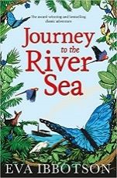
Rooftoppers Journey to the River Sea The Ruby In The Smoke The Girl of Ink and Stars
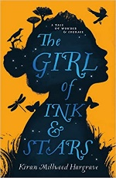
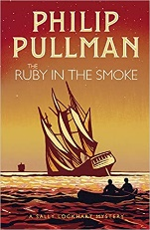
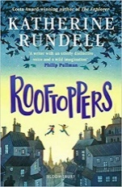

Geraldine McCaughrean Sally Gardiner Patrick Ness
Where The World Ends Tinder The Knife of Never Letting Go
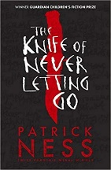
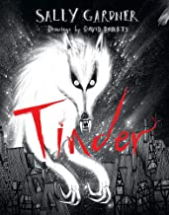
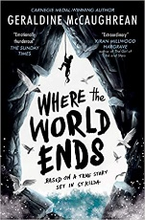
Brian Conaghan Kevin Brooks Anthony McGowan Neil Gaiman
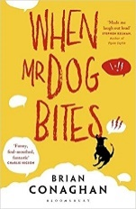
When Mr Dog Bites The Bunker Diary Lark The Graveyard Book
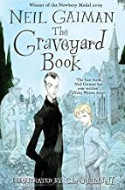
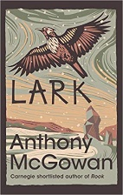
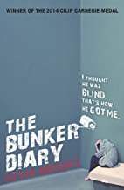

Judy Blume ` Sue Townsend
Just As Long As We’re Together The Secret Diary of Adrian Mole
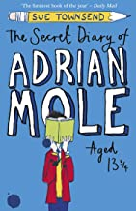
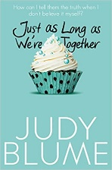
Douglas Adams Charles Dickens Markus Zusak
The Hitchhiker’s Guide To The Galaxy A Christmas Carol The Book Thief
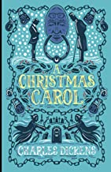
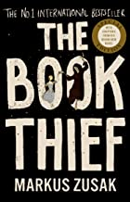
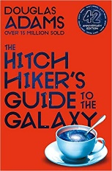

Onjali Q Rauf Meg Rosoff John Young
The Boy At The Back of The Class How I Live Now Farewell Tour of the Terminal
Optimist
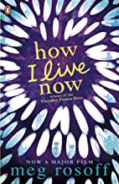
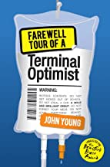
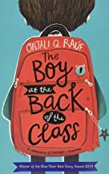

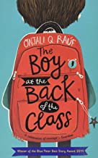
Malorie Blackman Ray Bradbury Michelle Paver Sarah Crossan
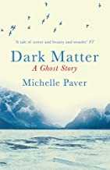
Noughts and Crosses Fahrenheit 451 Dark Matter One
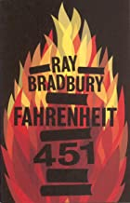
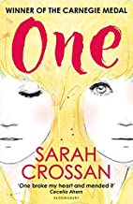
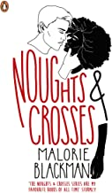

Ernest Cline Angie Thomas Andrew Smith
Ready Player One The Hate You Give Grasshopper Jungle
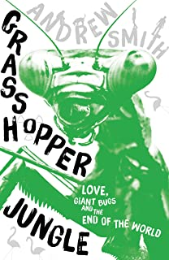
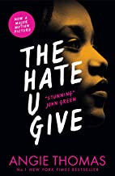
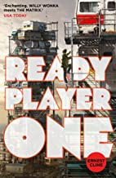

Bill Bryson Hans Rosling
A Short History of Nearly Everything Factfulness
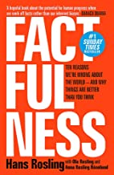
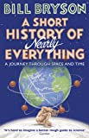

Art Spiegelman Marjane Satrapi
Maus Persepolis
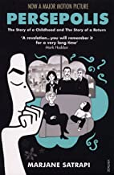

Read one and now looking for something similar?
Check out our ‘If you read this, you might like…’ recommendations and the Bookflix board in our corridor.

