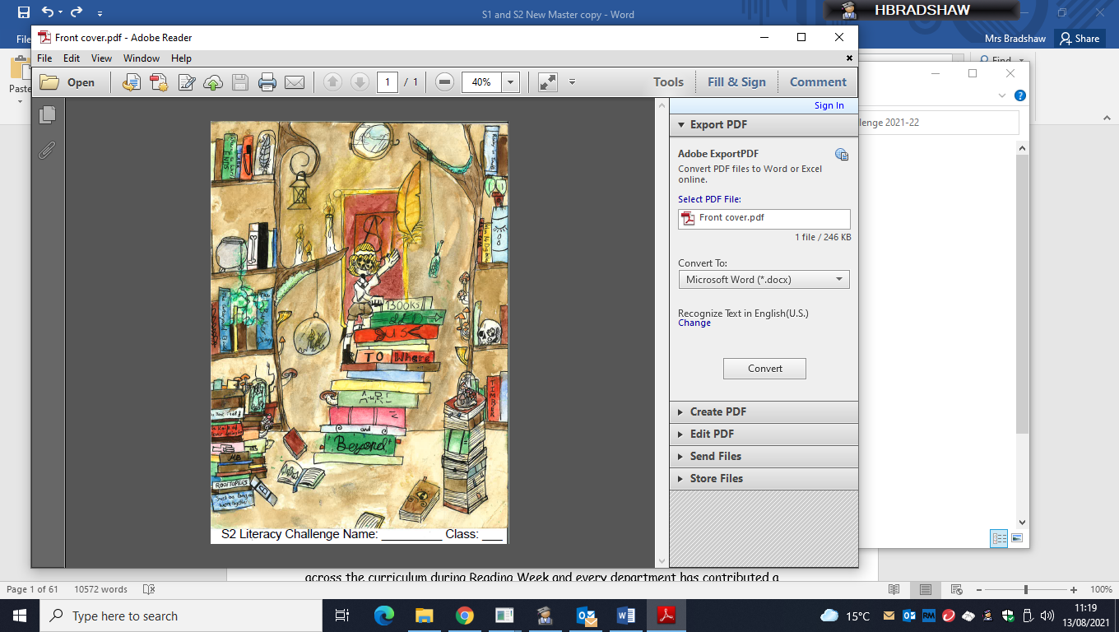

**Strathaven Academy**

**Literacy Committee**

Dear Parent/Carer,

The literacy challenge booklet has been designed to encourage your child to work independently and to encourage progression and enjoyment in reading from primary/S1. It should also help your child to develop good study habits.

Your child will be expected to read every day and to log their reading habits. Pupils are expected to set their own challenging target of up to 30 texts* across the session. Pupils are encouraged to read a variety of texts, to borrow books from the school and class libraries or to bring books from home or the local library.

Numerous educational studies point to the link between a regular reading habit and educational improvement. Pupils are therefore given time to read in registration and during English class and are expected to bring a book and their Literacy Challenge booklet with them every day.

We also ask pupils to read for at least 10 minutes at home every day. This forms the daily homework set by the English Department.

Reading is supported and encouraged throughout the school; we celebrate reading across the curriculum during Reading Week and every department has contributed a subject-specific reading exercise to the Literacy Challenge which pupils will complete as homework when requested to do so.

The rest of the Literacy Challenge booklet forms the bulk of the homework programme for the English Department. Pupils will be set a weekly or fortnightly task designed to allow pupils to reflect on what has been read and enjoyed.

The good habits that homework develops should be highly regarded and to achieve the most from these exercises pupils should complete them on time and to the best of their ability. Should there be any concerns about the progress your child is making the school will keep you informed.

In the meantime, should you have any concerns or questions please do not hesitate to contact Helen Bradshaw on 01357 524040

The English Department (on behalf of the Literacy Committee)

Parent/Carer’s signature ______________________________

Pupil Signature: ______________________________________

*Texts are defined as: novels, short stories, plays, poems, reference texts, the spoken word, charts, maps, graphs and timetables, advertisements, promotional leaflets, comics, newspapers and magazines, CVs, letters and emails. films, games and TV programmes, posters, recipes, manuals and instructions, reports and reviews , blogs and social networking sites, web pages, catalogues and directories

 Strathaven Academy Literacy Challenge Date Set: ______________ Date Due: ____________

**Attitudes to Reading for Pleasure**

Before you begin your reading and literacy challenge take time to reflect on your reading habits and your attitudes towards reading for pleasure.

Take the survey on your Google Classroom.

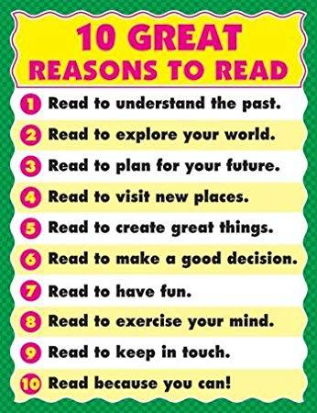

**Fake Reading**

* **Not reading the pages**
* **Flipping the pages**
* **Only looking at pictures**
* **Reading entire chapter/book in 5 minutes**
* **Looking around**
* **‘Pretending’ to be reading**
* **Skipping pages**
* **Staying on the same page**
* **Talking with friends**
* **Generic comments**

**Real Reading**

* **Focussed on pages (actually *reading* the words)**
* **No talking**
* **Pacing (fluency)**
* **Not wanting to put it down**
* **Asking questions**
* **Visualising (mental images**
* **Making predictions**
* **Confirming/revising predictions**
* **Being totally mesmerised**
* **Putting yourself in the character’s shoes**

**VS**

 Strathaven Academy Literacy Challenge Date Set: ______________ Date Due: ____________

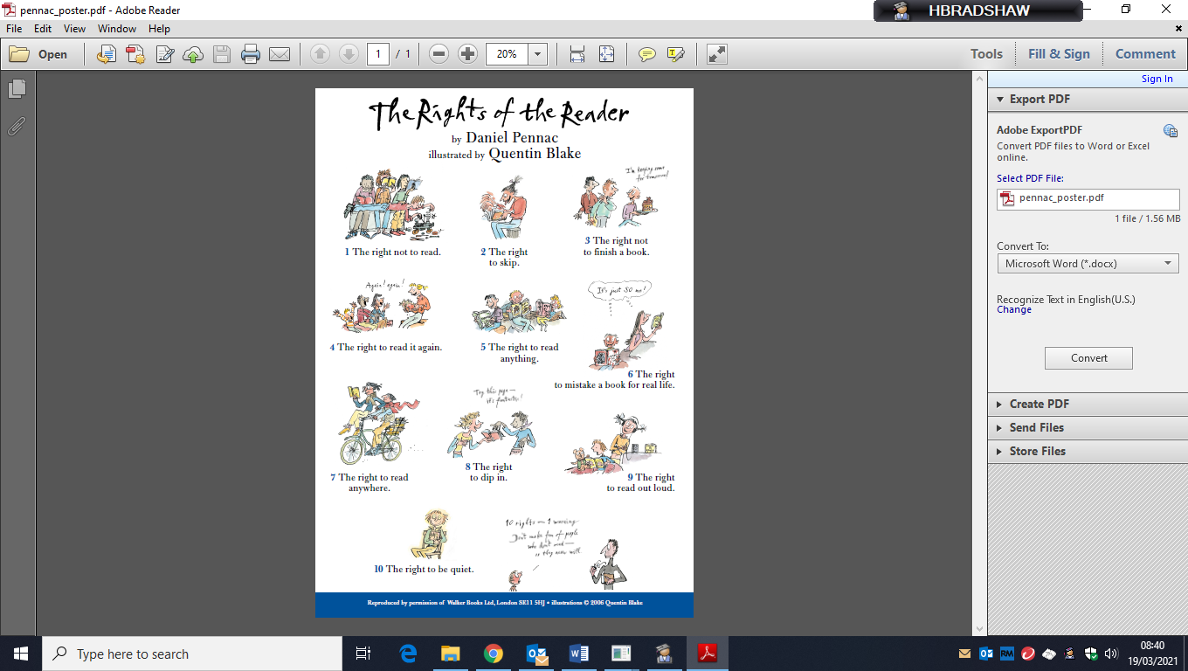

Do you feel you have these rights as a reader? Are there any other rights you have or feel you should be entitled to as a reader? Why?

 Strathaven Academy Literacy Challenge Date Set: ______________ Date Due: ____________

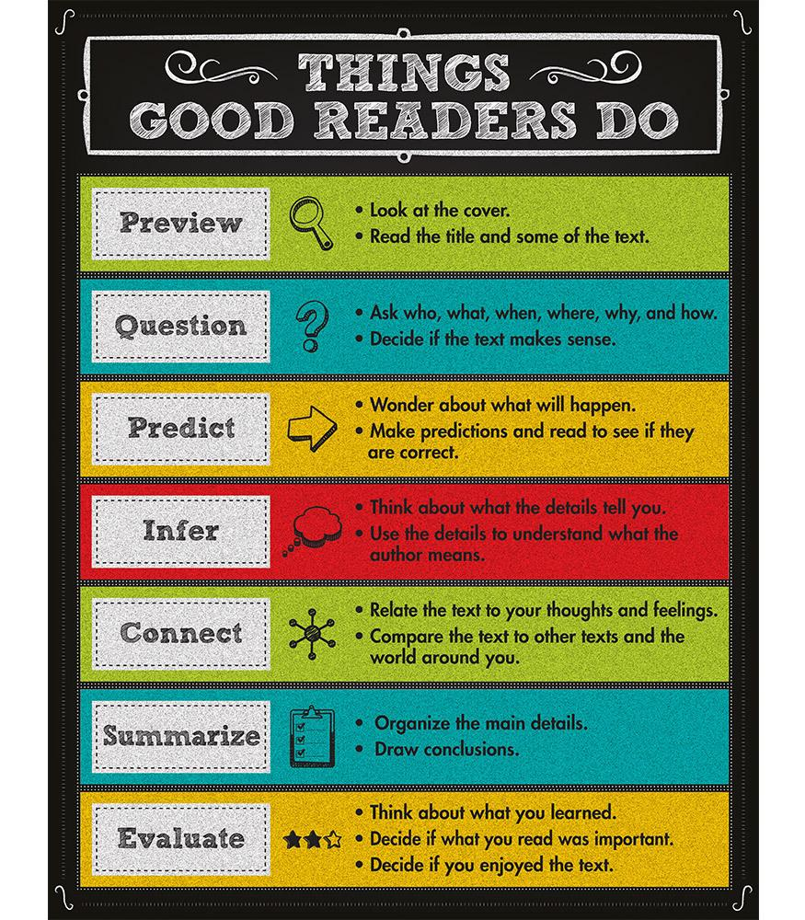

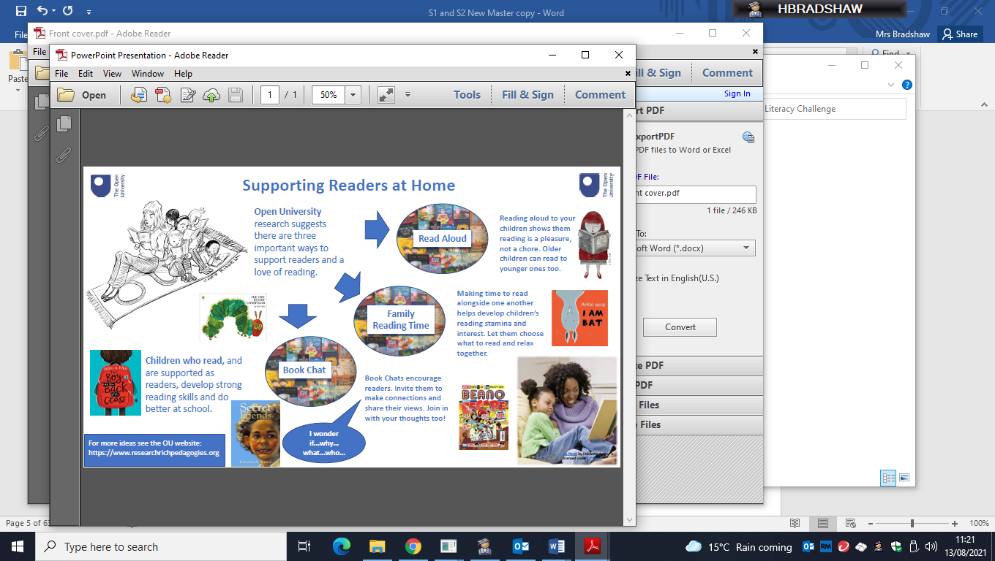

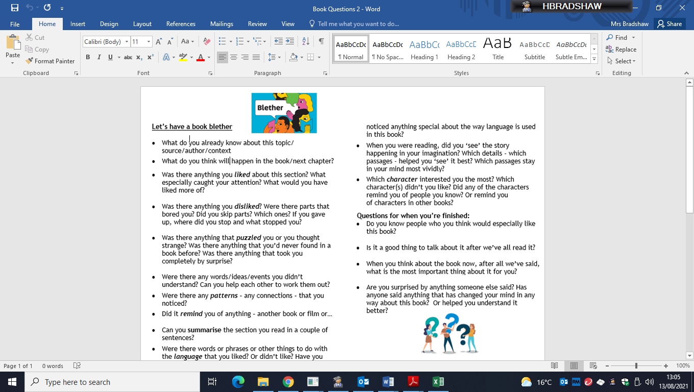

**I don’t know what to read.**

**Where do I start?**

|  |
| --- |
| <https://www.cranachanpublishing.co.uk/stay-at-home-2/>  ***Stay at Home*** is a free online book published by a Scottish Book publisher, *Cranachan.* It is full of short stories and poems about living life in lockdown. |

|  |
| --- |
| Ultimate Football Heroes LogoFootballing short story, *Vardy,* by Matt Oldfield, one of the writers of the Ultimate Football Heroes series  https://heroesfootball.com/wp-content/uploads/2020/05/Vardy-story.pdf |

|  |
| --- |
| **Audio Recordings**  Brilliant, short audio recordings of Shakespeare’s famous tales retold.  <https://www.bbc.co.uk/teach/school-radio/english-ks2-shakespeare-retold-index/zh4h2sg>  You can also listen online to Michael Morpurgo’s novel, *War Horse* which is told in sections: <https://www.bbc.co.uk/teach/school-radio/english-ks2-war-horse-michael-morpurgo/zmpwbdm>  https://www.roalddahl.com/40414_IMAGE_0*480,0,480x166,1;0*480,0,960x332,2;481*768,0,768x265,1;481*768,0,1536x530,2;769*9999,0,1245x430,1;769*9999,0,2490x860,2_14844_.jpgDuring the 2020 lockdown, award-winning filmmaker, Taika Waititi, read ***James and the Giant Peach*** by Roald Dahl to raise money for charity, helped out by some famous friends. You can still watch the first part of the novel being read here:  <https://www.youtube.com/watch?v=29LDBdpNMRc&list=RDCMUCPPBUXEAvZNrTNXUJ4WHIKA&start_radio=1&t=986>  (17-minute clip)  Audiobooks: The happy medium of spoken-word literature  **Free audio books to listen to from Audible**  <https://stories.audible.com/discovery> |

|  |
| --- |
| BookofHopes.jpg***The Book of Hopes*** is a collection of short stories, poems, essays and pictures to read online but it has also been published as a book you can buy. It has contributions from more than 110 children’s writers and illustrators, including, Anthony Horowitz, Greg James and Chris Smith, Michael Morpurgo, Liz Pichon, Axel Scheffler, Francesca Simon and Jacqueline Wilson.  [**https://issuu.com/bloomsburypublishing/docs/thebookofhopes_interactivepdf**](https://issuu.com/bloomsburypublishing/docs/thebookofhopes_interactivepdf) |

|  |
| --- |
| **Opening Chapters** – reading first chapters of books is a good way to see whether you’d like to continue reading on.    [**https://www.lovereading4kids.co.uk/**](https://www.lovereading4kids.co.uk/)  **The Lovereading4kids website allows you to read opening chapters from a whole range of young adult books and you can search by age and genre. You will have to sign up to log in but it is free to do so.** |

|  |
| --- |
| **Non-fiction reading recommendations**  National Geographic Kids – interviews and facts from all around the world!  <https://www.natgeokids.com/uk/category/discover/>  Keep up to date with all the important news and topical topics here:  <https://www.bbc.co.uk/newsround/news/watch_newsround>  The Day  We have a subscription to The Day newspaper aimed at S1-S3 pupils. You can find it here: [www.theday.co.uk](http://www.theday.co.uk)  Login with the username Strathaven and password theday |

|  |
| --- |
| Bookzilla - Scottish Book Trust**Bookzilla** is a great app for finding book recommendations and recording your reads and it is aimed at S1-S3 pupils. You can download it from the Apple Store or Get it on Google Play. |

|  |
| --- |
| **Use your South Lanarkshire Council Library membership** to access ebooks and e-Audiobooks for free. See <https://www.sllclibrary.co.uk/cgi-bin/spydus.exe/MSGTRN/WPAC/HOME> for further details. |

|  |
| --- |
| Access lots of reviews and ideas for new reading material here:  The Reading Realm - <https://thereadingrealm.co.uk/category/resources/>  Toppsta - <https://toppsta.com/>  Books for Keeps book magazine for young people - <http://booksforkeeps.co.uk/>  Love my books - <http://www.lovemybooks.co.uk/>  Read brightly - <https://www.readbrightly.com/>  Reading Zone - <https://www.readingzone.com/>  Graphic novels padlet - <https://padlet.com/rruddick9zra/73uh2srzpbia>  Library Boy and Book Girl - <https://librarygirlandbookboy.com/category/tweens/>  Reading for Pleasure Tube Map  <https://misterbodd.wordpress.com/2019/04/09/reading-for-pleasure-tube-map/amp/?__twitter_impression=true>  The Great British Bookworm - <https://thegreatbritishbookworm.wordpress.com/> |



**The ‘Strathaven Reads’ (for Pleasure) Canon**

How many can you read in S1 – S3?

Katharine Rundell Eva Ibbotson Philip Pullman Kiran Millwood Hargrave

Rooftoppers Journey to the River Sea The Ruby In The Smoke The Girl of Ink and Stars

Geraldine McCaughrean Sally Gardiner Patrick Ness

Where The World Ends Tinder The Knife of Never Letting Go

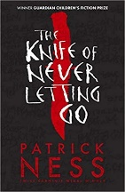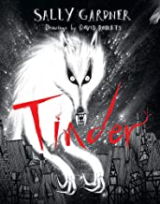

Brian Conaghan Kevin Brooks Anthony McGowan Neil Gaiman

When Mr Dog Bites The Bunker Diary Lark The Graveyard Book

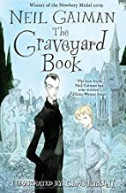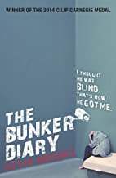

Judy Blume ` Sue Townsend

Just As Long As We’re Together The Secret Diary of Adrian Mole

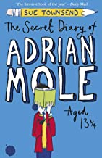

Douglas Adams Charles Dickens Markus Zusak

The Hitchhiker’s Guide To The Galaxy A Christmas Carol The Book Thief

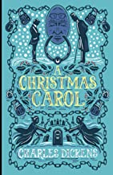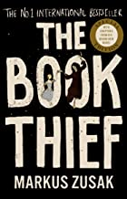

Onjali Q Rauf Meg Rosoff John Young

The Boy At The Back of The Class How I Live Now Farewell Tour of the Terminal

Optimist

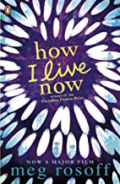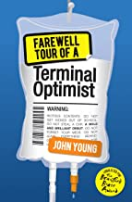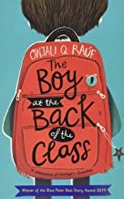

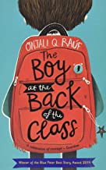Malorie Blackman Ray Bradbury Michelle Paver Sarah Crossan

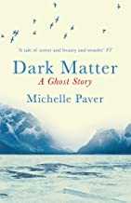Noughts and Crosses Fahrenheit 451 Dark Matter One

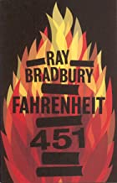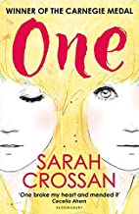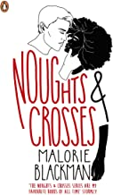

Ernest Cline Angie Thomas Andrew Smith

Ready Player One The Hate You Give Grasshopper Jungle

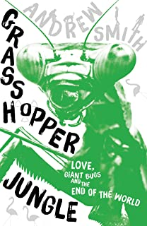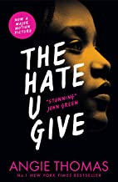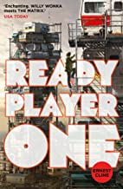

Bill Bryson Hans Rosling

A Short History of Nearly Everything Factfulness

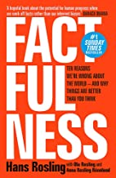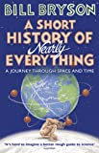

Art Spiegelman Marjane Satrapi

Maus Persepolis

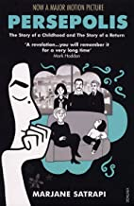

Read one and now looking for something similar?

Check out our ‘If you read this, you might like…’ recommendations.

We challenge you to read for pleasure as much as you can for this year! Choose your challenge!

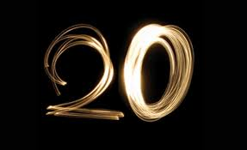You might want to set a target for the number of texts you want to read this year.

Your target might be to complete a book on your own this year OR to work on improving your independent reading skills.

You might want to work on changing your attitude towards reading OR to broadening your reading diet to include non-fiction, science fiction, crime, fantasy…

Perhaps you are ready for more challenging reads and want to explore Young Adult or Senior Fiction.

Whatever your reading challenge is, write it in the space below and share it with your teacher.

My Challenge/Target(s) is: ________________________________

I picked this target/challenge because

 Strathaven Academy Literacy Challenge Date Set: ______________ Date Due: ____________

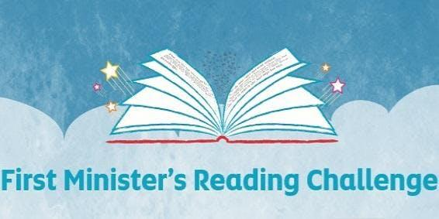

**Reading Challenge**

Each time you finish a book keep a note of the text and author on the spine of one of the books on your bookshelf.

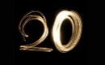

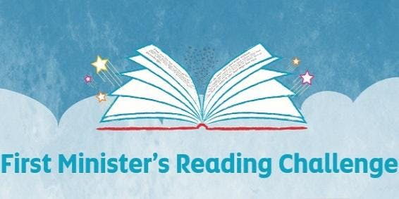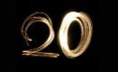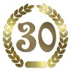

**My Reading Challenge Record**

Keep a record of your progress on this page. You could list all the books you have read this session **OR** you could stick pictures of completed books **OR** to show your changing reading habits **OR** to show the variety of texts you have read.

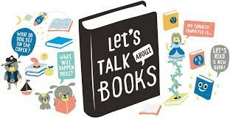

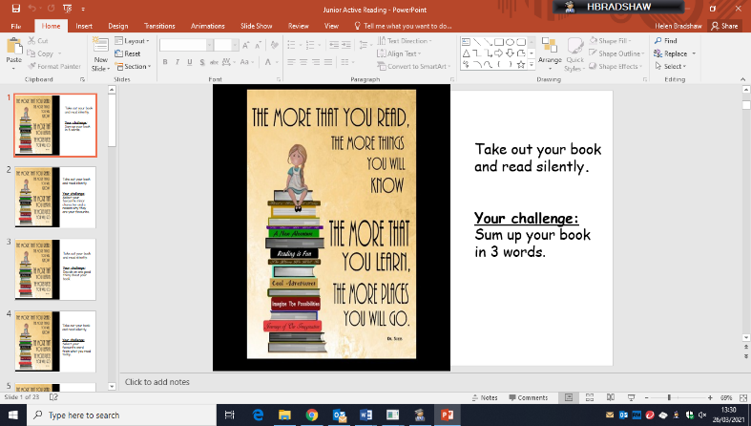**Text Talk Time**

Use your reading time today to talk to your partner about what you are reading. Your teacher might set you an Active Reading Task or one of the following tasks.

**Speed Dating**

Prepare a short summary – thirty seconds to a minute long – selling the book you are currently reading to a classmate.

You need to be able to sell your book and listen to your partner’s summary before you move on.

At the end you must write the name of the book you most liked the sound of on a post it note.



**Home Reading**

Discuss where you like to read best. Perhaps share a picture of your favourite reading space.

Bring in anything you have read recently to show your partner and to display on the reading area in your English classroom. It could be social media, comics, magazines, books, newspapers, junk mail, game-related reading...

Theme Weeks

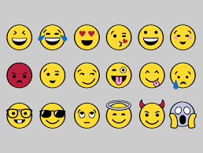Choose a theme for everybody’s reading next week – it might be books about an idea/theme e.g. fear or journeys OR it might be an author or choice of author OR it might be non-fiction or comics/graphic novels…

**Emoji Recommendations**

Stick pictures of recent enjoyed reads on your Reading Wall. Use emojis to show your emotions reading the book.

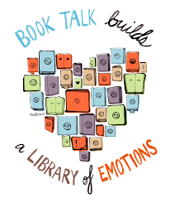**Book to Film**

**Watch a film inspired by or based on a book you have read. Compare and contrast.**

**Newspaper Challenge**

Read a news article from the source below (or any other quality broadsheet newspaper or news website) and summarise the content. Use your own words.

[www.bbc.co.uk/newsround/33078510](http://www.bbc.co.uk/newsround/33078510)

|  |  |  |  |
| --- | --- | --- | --- |
| **Date** | **Headline** | **Summary** | **Writer’s Attitude?** |
|  |  |  |  |
|  |  |  |  |
|  |  |  |  |
|  |  |  |  |

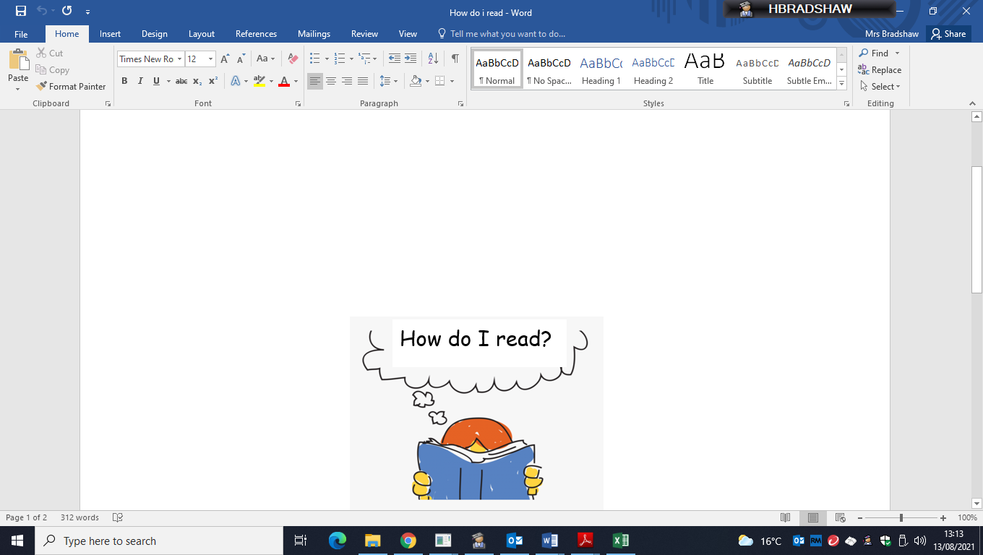

My Reading History

**Picture books.**

Which books did you enjoy looking at or being read to you before you could read/as you learned to read?

**Primary books.**

Which books do you remember from being read to the class at primary school?

**My First Independent Reads.**

What were the first books you enjoyed reading by yourself?

**Secondary school reads.**

What books have you enjoyed in class or reading alone as a teenager/at secondary school?

**Recent reads.**

What books have you enjoyed most recently that you recommend or that you would recommend to others?

**Magazines and newspapers I have loved throughout my life.**

What magazines, comics or newspapers did you enjoy in the past and which ones do you enjoy now?

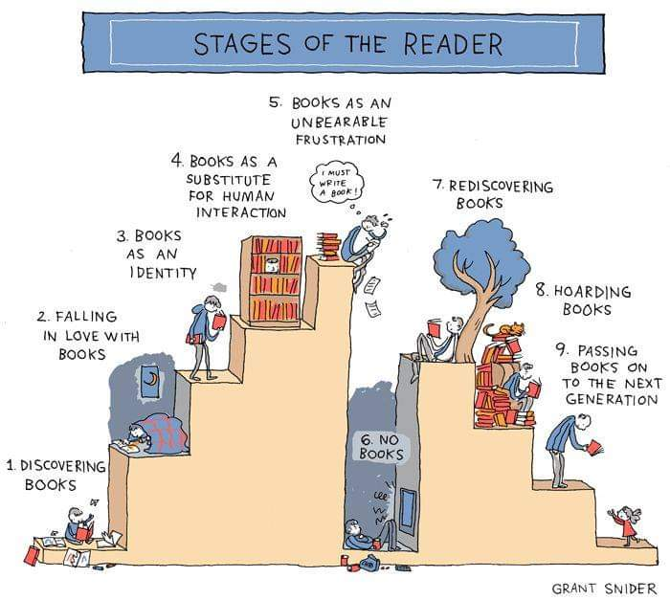

**Books I have hated.**

What books have you hated or given up on?

Outline your journey as a reader. You can use whatever format you like to show off your reading history.

Why not bring in a favourite picture book to share? What made this book important to you? Who read it to you? Where you read it? The pictures?...

 Strathaven Academy Literacy Challenge Date Set: ______________ Date Due: ____________



**Desert Island Reads**

Have you ever listened to (or heard of) the long-running BBC Radio 4 programme ‘Desert Island Discs’. In the programme guests select the songs and books that they couldn’t live without if they were stranded on a desert island. They then explain their choices.

Imagine that you have been stranded on a remote desert island. You are going to be stranded on the island for some time and you will need something to keep you occupied. All that has washed up with you is a crate which contains books.

Select three books you would be happy to re-read on your desert island – books that will keep you occupied until you are rescued.

Why have you chosen these three books? You could mention setting, plot, character, theme, humour, author….

You might also need some fuel for your fire. Select a book that you wouldn’t mind sacrificing. Why have you chosen this book?

Share you choices and your reasons with your partner/group/class.

Now, prepare a colourful and attractive poster which not only makes clear your top desert island book but also the reasons you have chosen it.

 Strathaven Academy Literacy Challenge Date Set: ______________ Date Due: ____________



**Reading Detectives**

**Find out about what, how and why other people like to read.**

**Your teacher will set you one or two of the following tasks to do in class in pairs or for homework**

* Design your own questionnaire to investigate how others view reading.

OR

* To find out about their reading habits.
  + Do they skip long descriptive passages in books?
  + Read the end before they get there?
  + Skim forward and check backwards/re-read to find out something?
  + Re-read passages to help remember events or characters?
  + Turn the pages down or use a bookmark?
  + Flick through the book?
  + Make connections with their own lives?
  + Get lost in the book?
  + Do these habits vary according to the kind of reading material?....
* 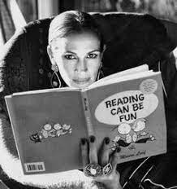Pick a family member or a famous person in whom you are interested and find out what they are reading and what they like to read. Think about how you will display your findings.

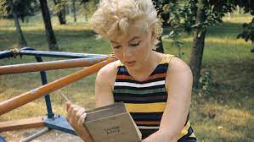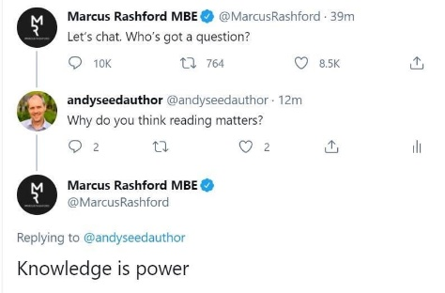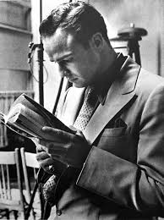

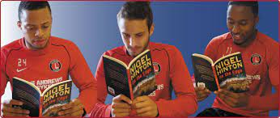





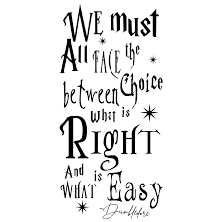**Choose a quotation from a character or a poem or a story or a song that you love.**

**Illustrate your quote so that others will love it too!**



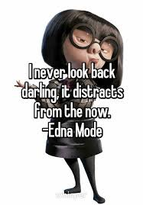

 Strathaven Academy Literacy Challenge

Date Set: ______________ Date Due: ____________

Found poetry is a type of poetry created by taking words, phrases, and sometimes whole passages from other sources to make poetry (like a literary equivalent of a collage) by making changes in spacing and lines, or by adding or deleting text, thereby making new meaning.

Look at the examples below and then, using a page from your reading book, make a found poem of your own (you don’t have to photocopy or write on your book like the examples – you can just write out your poem).

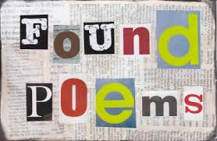

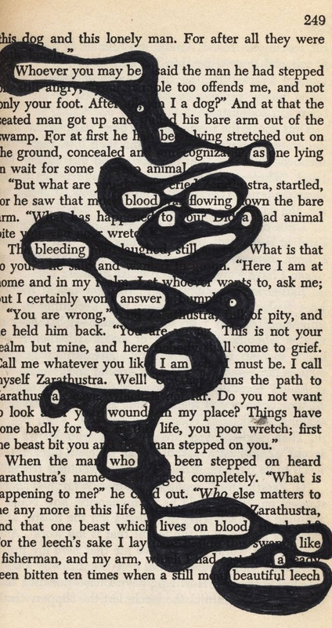

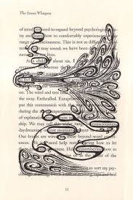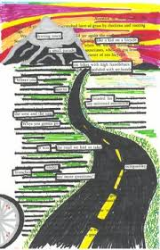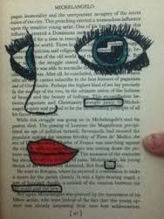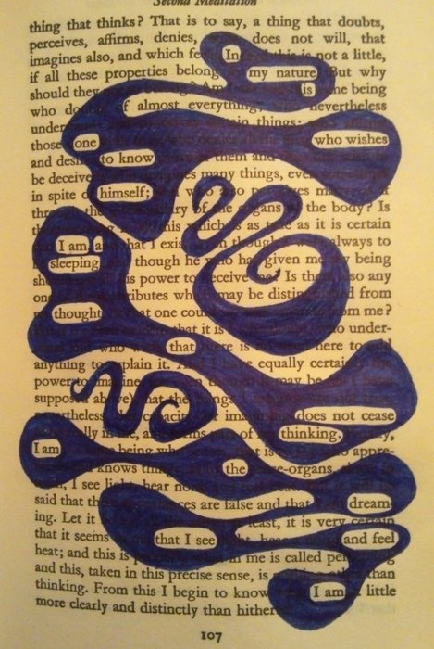

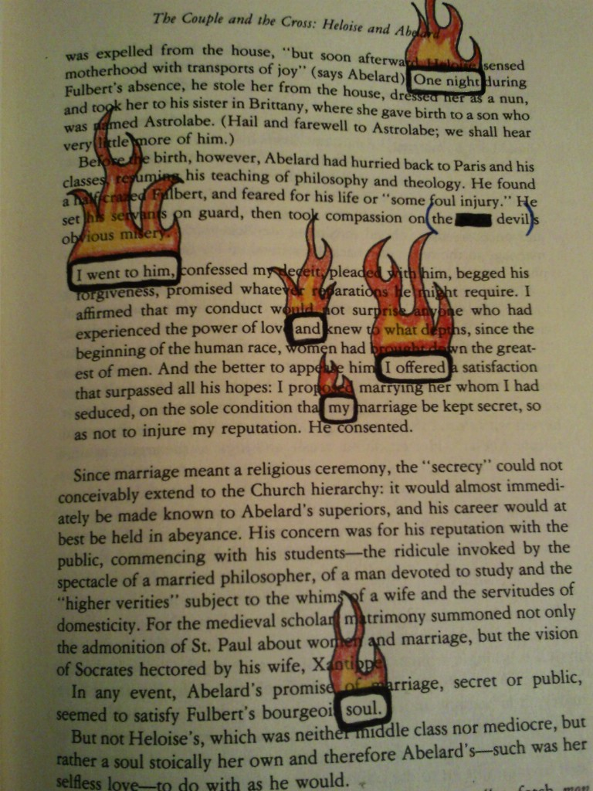

 Strathaven Academy Literacy Challenge Date Set: ______________ Date Due: ____________

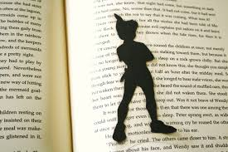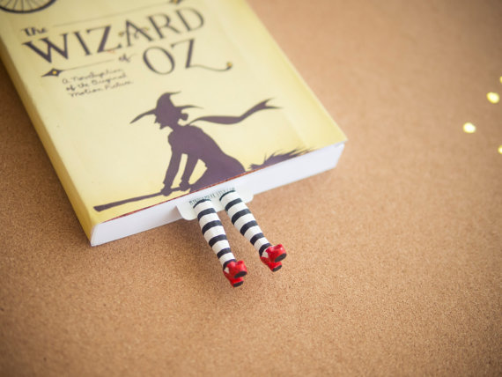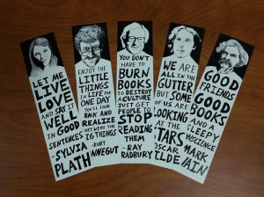

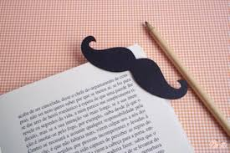

**Bookmark!**

Make a bookmark for your favourite or current reading book.

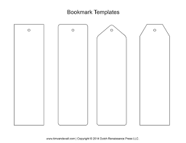

 Strathaven Academy Literacy Challenge Date Set: ______________ Date Due: ____________

Bring a Book

to Life

In this task you need to choose a favourite page in your book or a book you have recently read and loved. Your job is to bring the events on that page to life, on the page itself. Look at the examples for inspiration.

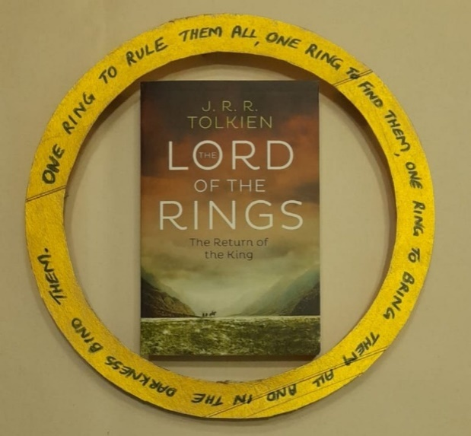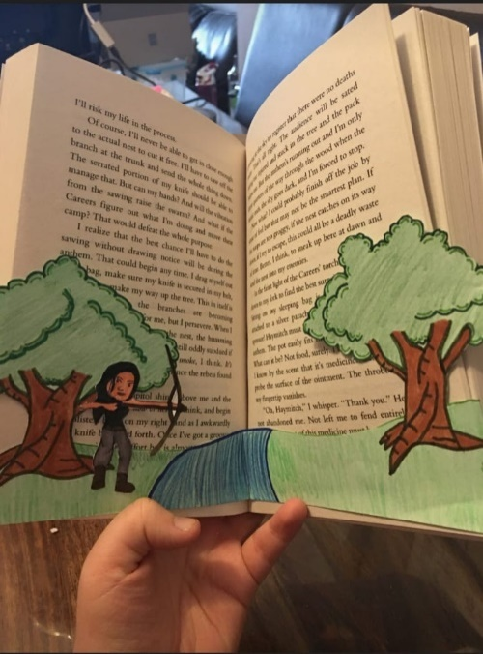

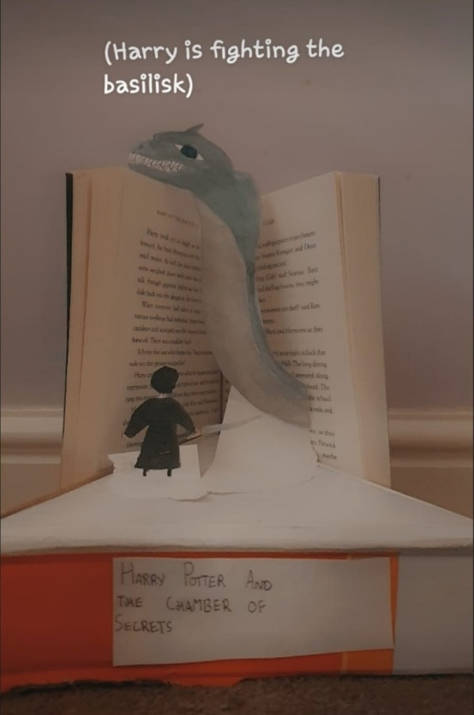

 Strathaven Academy Literacy Challenge

Date Set: ______________ Date Due: ____________

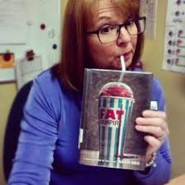

**Bookface Challenge**

**Bookface** involves carefully lining up your face or body alongside a book cover that features a matching body part so that there appears to be a combining of life and art.

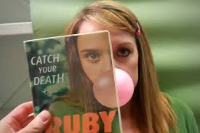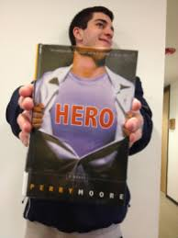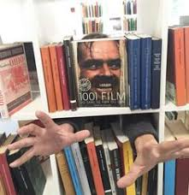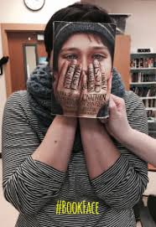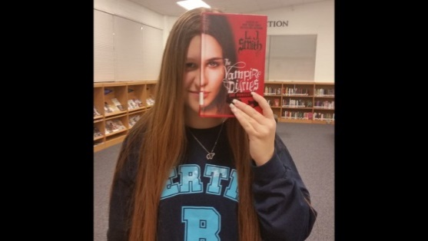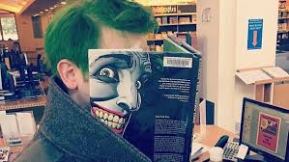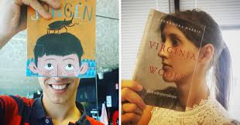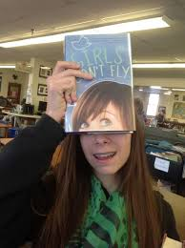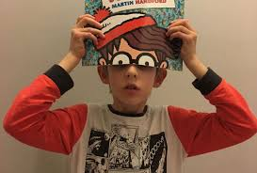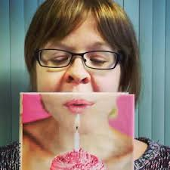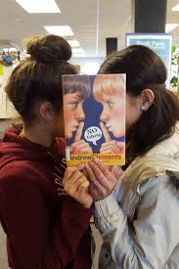

 Strathaven Academy Literacy Challenge

Date Set: ______________

Date Due: ____________

**Reading Challenge**

**S1 Numeracy Week**

**Snowball Poetry**

A snowball poem is a poem in which you start with one word and then move to two words in the next line and then three words in line three and so on. The poem can continue to climb or it can come back down again.

Your task is to write a snowball poem on a topic of your choice.

Each line must have one more word than the previous line.

For example

Cold.  
Numb fingers.  
My breath freezes.  
Can't feel my toes.  
I have sent for help.  
Please God, when will it come?  
I have done nothing to deserve this.  
Stuck out here in the wind and snow.

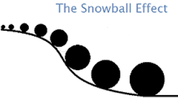

 Strathaven Academy Literacy Challenge Date Set: ______________ Date Due: ____________

**Reading Challenge**: Write a 100 word summary of your book – NOT 101 or 99…100 exactly! (Tip: Start with the main character’s name)

 Strathaven Academy Literacy Challenge Date Set: ______________ Date Due: ____________

**Reading Challenge:** Write a 100 word summary of your book – NOT 101 or 99…100 exactly! (Tip: Start with the main character’s name)

 Strathaven Academy Literacy Challenge Date Set: ______________ Date Due: ____________

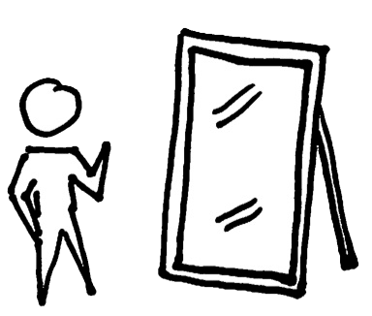**Reading Reflections**

You should regularly reflect on your reading. Here you can have a ‘conversation’ with your teacher about your reading.

* What are you liking/disliking about your book?
* What puzzles you about the text?
* Does it remind you of anything else?
* What do you think will happen next?.........

|  |
| --- |
| **Week beginning: _____________ Reading Reflections** |
| **Week beginning: _____________ Reading Reflections** |
| **Week beginning: _____________ Reading Reflections** |
| **Week beginning: _____________ Reading Reflections** |
| **Week beginning: _____________ Reading Reflections** |
| **Week beginning: _____________ Reading Reflections** |
| **Week beginning: _____________ Reading Reflections** |
| **Week beginning: _____________ Reading Reflections** |
| **Week beginning: _____________ Reading Reflections** |
| **Week beginning: _____________ Reading Reflections** |
| **Week beginning: _____________ Reading Reflections** |

**Write to…Imagine**

On a cold, fretful afternoon in early October 1872, a hansom cab drew up outside the offices of Lockhart and Selby, Shipping Agents in the financial heart of London, and a young girl got our and paid the driver.

She was a person of sixteen or so – alone, and uncommonly pretty. She was slender and pale, and dressed in mourning, with a black bonnet under which she tucked back a straying twist of blonde hair that the wind had teased loose. She has unusually dark brown eyes for one so fair. Her name was Sally Lockhart; and within fifteen minutes she was going to kill a man. (‘The Ruby in the Smoke’ by Philip Pullman)

Alex was sure he was going to suffocate.

Crouched in the tiny, pitch-black bucketing space, legs drawn up to his chin, sweat running down his face, handkerchief sodden, head pounding, the panic raged inside him. He wanted to scream and beat at the plastic walls. Instead, he remained petrified by the continuous vibration, the sour smell of his tomb. (‘Day of the Dead’ by Anthony Masters)

**Discuss**: What makes an attention-grabbing opening to a story. Use the 2 examples to help.

**Write**: To create an exciting opening to a story using at least one of these 4 items

A rusty key 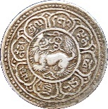A foreign coin 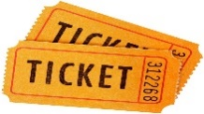A bus ticket A button

__________________________________________________________________________________________________________________________________________________________________________________________________________________________________________________________________________________________________________________________________________________________________________________________________________________________________________________________________

_________________________________________________________________________________________________________________________________________________________________________________________________________________________________

___________________________________________________________________________

__________________________________________________________________________________________________________________________________________________________________________________________________________________________________________________________________________________________________________________________________________________________________________________________________________________________________________________________________

_________________________________________________________________________________________________________________________________________________________________________________________________________________________________

 Strathaven Academy Literacy Challenge Date Set: ______________ Date Due: ____________

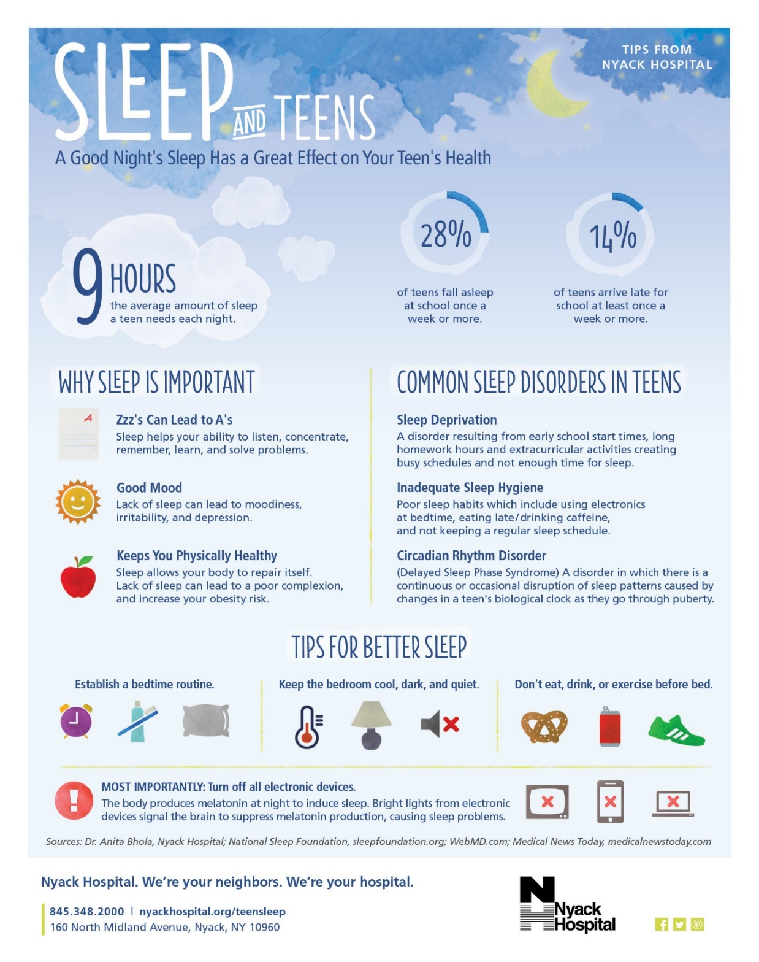**Write to…**

**Argue**

**Discuss**:

How you would

put forward a

convincing

argument for

something.

What are the

benefits of a

later school start

time for

secondary school

pupils?

**Write**: An argument for later school hours.

____________________________________________________________________________________________________________________________________________________________________________________________________________________________________________________________________________________________________________________________________________________________________________________________________________________________________________________________________________________________________________________________________________________________________________________________________________________________________________________________________________________________________________________________________________________________________________________________________________________________________________________

________________________________________________________________________________________________________________________________________________________________________________________________________________________________________________________________________________________________________________________________________

 Strathaven Academy Literacy Challenge Date Set: ______________ Date Due: ____________

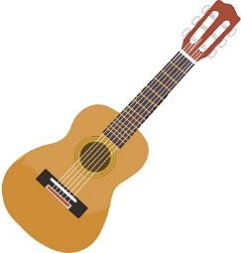**Write to…Remember and Reflect**

The most valuable possession in my room is an old, slightly warped cherry red guitar-the first instrument I taught myself how to play. It's nothing fancy, just a Madeira folk guitar, all scuffed and scratched and finger-printed. At the top is a bramble of copper-wound strings, each one hooked through the eye of a silver tuning key. The strings are stretched down a long, slim neck, its frets tarnished, the wood worn by years of fingers pressing chords and picking notes. The body of the Madeira is shaped like an enormous yellow pear, one that was slightly damaged in shipping. The wood has been chipped and gouged to grey, particularly where the pick guard fell off years ago. No, it's not a beautiful instrument, but it still lets me make music, and for that I will always treasure it.

**Discuss:** What prompts a strong memory? What techniques are used by this writer to show how important this object was/is?

**Write:** to describe and reflect on the significance of a favourite childhood toy

__________________________________________________________________________________________________________________________________________________________________________________________________________________________________________________________________________________________________________________________________________________________________________________________________________________________________________________________________

_________________________________________________________________________________________________________________________________________________________________________________________________________________________________

___________________________________________________________________________

__________________________________________________________________________________________________________________________________________________________________________________________________________________________________________________________________________________________________________________________________________________________________________________________________________________________________________________________________

__________________________________________________________________________________________________________________________________________________________________________________________________________________________________________________________________________________________________________________________________________________________________________________________________________________________________________________________________

_________________________________________________________________________________________________________________________________________________________________________________________________________________________________

___________________________________________________________________________

___________________________________________________________________________

 Strathaven Academy Literacy Challenge Date Set: ______________ Date Due: ____________

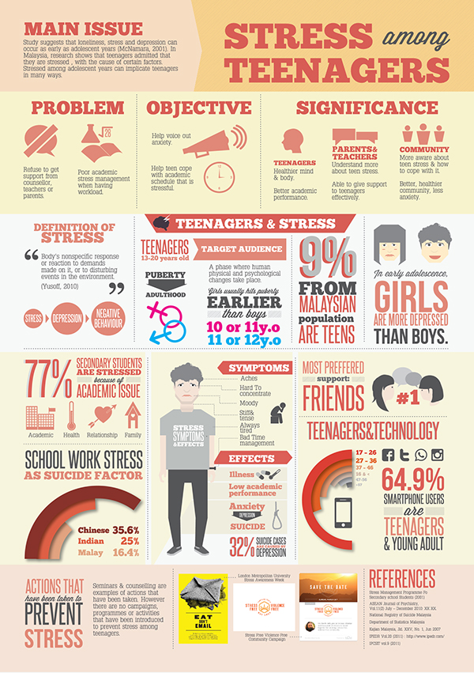**Write to…Inform**

**Discuss**: What causes

stress among teenagers

and how

it can be reduced.

The difference between

fact and opinion.

**Write**: To give information about the main cause of stress among teenagers, its main effect and a solution

__________________________________________________________________________________________________________________________________________________________________________________________________________________________________________________________________________________________________________________________________________________________________________________________________________________________________________________________________

_________________________________________________________________________________________________________________________________________________________________________________________________________________________________

___________________________________________________________________________

 Strathaven Academy Literacy Challenge Date Set: ______________ Date Due: ____________

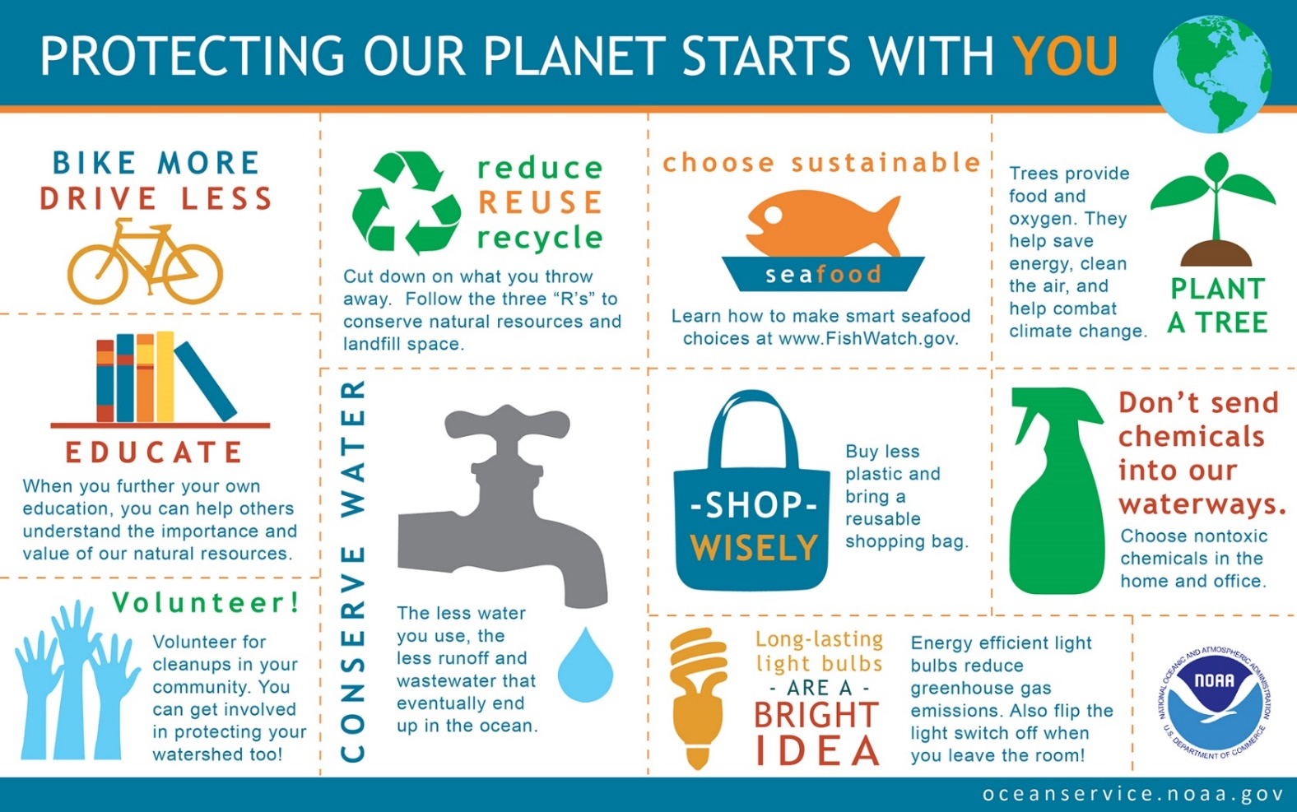**Write to…Explain**

**Discuss:** How to explain clearly**.** Who is responsible for ensuring the future of the planet?

**Write:** To explain how individuals can help to protect the planet.

__________________________________________________________________________________________________________________________________________________________________________________________________________________________________________________________________________________________________________________________________________________________________________________________________________________________________________________________________

_________________________________________________________________________________________________________________________________________________________________________________________________________________________________

___________________________________________________________________________

__________________________________________________________________________________________________________________________________________________________________________________________________________________________________________________________________________________________________________________________________________________________________________________________________________________________________________________________________

 Strathaven Academy Literacy Challenge Date Set: ______________ Date Due: ____________

Compare two fast foods/ or two fast food restaurants. Say which you prefer and why.

OR

Present an argument in favour of a four-day school week.

OR

Write an argument against school uniform.

OR

You are the only carrot left in the fridge. Write about your feelings and your hopes for the future.

OR

You are an old coin that someone has found in the street. Write about your life.

OR

What if humans had tails? Write a short essay in which you explain how the world would be different.

OR

Write a review of a meal you recently enjoyed. Describe it and say what you liked about it and what could make it even better.

OR

Write a review an item of clothing that you like to wear: shoes, jacket, leisure wear, hats etc…

OR

Write a review of a place you have recently visited. Point out its most notable features and say what you liked/disliked about it.

OR

Write a page about the rules of a game that you play or have played when you were younger.

OR

Write a set of instructions on how to stay in bed as long as possible but still get to school on time

OR

What if you were invisible? Describe what things you would do and where you would like to go.

OR

“Kids believe anything.” Did you believe anything as a child that you later found out to be untrue?

OR

Write a letter to the head teacher of your school requesting that all tests and exams be banned.

 Strathaven Academy Literacy Challenge Date Set: ______________ Date Due: ____________