Strathaven Academy
Study Skills
A guide to study, assessment and examination techniques

How do you learn?

We are all unique individuals and therefore we all learn differently. You need to find the way that works best for you. For example, if you listen better than you read use audio.

Research shows that people remember:
- 10% of what they read
- 20% of what they hear
- 30% of what they see
- 50% of what they both see and hear
- 70% of what they say
- 90% of what they simultaneously say and do

Different techniques
- Summarise your notes
- Mnemonics
- Creative thinking – 10 min blast
- Spider diagrams
- Mind maps
- Flash cards
- Post it notes
- record yourself making key points and listen to them while you go for a walk
- use flashcards or an app to test yourself
- Get parent/ carer to quiz you on a topic you have just revised
The following pages include examples of the above techniques.

Identify Key Words

Identifying key words in a piece of text will help you to remember the main points more easily. Take this example:
"Napoleon was the emperor of France and the many other countries in Europe that he invaded. His empire collapsed after he over-stretched his forces and tried to invade Russia. His final defeat came at the hands of the Duke of Wellington at the battle of Waterloo."

To remember the important parts of the above passage, we should take the time to identify key points by either underlining or highlighting certain words, e.g.

“Napoleon was the emperor of France and the many other countries in Europe that he invaded. His empire collapsed after he over-stretched his forces and tried to invade Russia. His final defeat came at the hands of the Duke of Wellington at the battle of Waterloo."

NAPOLEON REMINDERS
Napoleon, emperor of France, Europe, invaded, empire collapsed,
invade Russia, final defeat, Duke of Wellington, Waterloo

When summarising your notes, you should concentrate on the key words in order to remember the facts more easily.

Summarising Notes

Summarising involves extracting key information from sources/paragraphs of information.

Many historians argue that women’s war efforts were vital in them gaining the vote in 1918. During the war women took over the jobs of men as bus drivers and conductors and tram drivers. Also, over 700,000 women took on extremely dangerous jobs in ammunition factories. Without women taking over these previously male dominated jobs, Britain would have struggled to have been prepared for war. Historians argue that women were given the vote in 1918 as a “thank you” for their efforts.

Key points of information from paragraph

- Women took over the jobs of men as bus drivers and conductors and tram drivers.
- 700,000 women took on extremely dangerous jobs in ammunition factories.
- Without women taking over these jobs, Britain would have struggled to have prepared for war.
- Women were given the vote in 1918 as a “thank you” for their efforts.

Mnemonics – pronounced NEM-ON-ICS

A mnemonic is a made-up word that helps you to remember things more easily.

For example, there is a mnemonic which makes it easier to remember the seven colours of the rainbow:

Red, Orange, Yellow, Green, Blue, Indigo, Violet
If you use the mnemonic ROY G BIV, remembering becomes much easier.

Another way to remember things with mnemonics is to use each of the letters in a made-up sentence. You only have to remember the sentence and you have the key points for your answer, e.g.

Richard Of York Gave Battle In Vain is an easy way to remember the seven colours of the rainbow.

This is especially useful in subjects where you have to remember a sequence of events. Memorise each of these mnemonics and you will remember them under exam pressure.

Creative Thinking
This is a good technique to use when you are having difficulty solving a problem. Perhaps you have to write an essay on a tricky subject. Creative thinking involves you taking just ten minutes to write down everything you know about the topic on a blank piece of paper.
It is important not to take too much time over this, you must work against the clock. Try it - it works!

Spidergrams/ Mind Maps

These are best completed in colour and with pictures. Imagine you are trying to make notes on all the different kinds of music.
- Write the word ’music’ in the middle of the sheet of paper
- Write the main types of music around this word, adding in more and more layers as you go.
- Divide each type as in the example below:

Music

Rock and pop

Classical

Jazz

Music

Rock and pop

Classical

Jazz
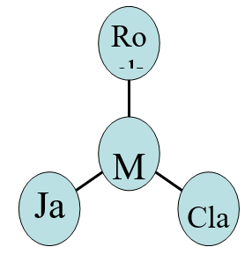

Mind Maps
Imagine you have to write an essay on the play Macbeth.
One way of planning this would be to take ten minutes to create a mind-map of ideas as shown here:
Step 1 In the centre of a blank piece of paper write down the focus of the essay question (for example an essay on how far we can sympathise with Macbeth).
Step 2 Draw a maximum of six lines coming out from this title.
Step 3 On each of the lines, write down words/ideas that relate to the focus of the essay e.g. actions, fate, other characters, setting, staging…
Step 4 Now you have a map of the central ideas for your essay. Each idea or theme could be one paragraph of the essay.
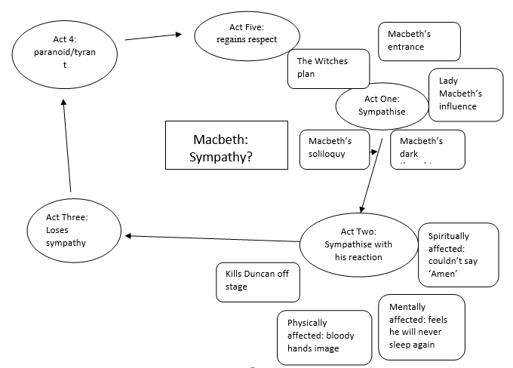

Flash Cards
An easy and simple way of repetitive learning. Write a title on each flash card then write the sub headings or small paragraph of information underneath. You can keep them in your pocket.
Post-it Notes
Making information visible is useful for retaining information. Write headings/ bullet points/ formulas and stick them where you can see them
Quick Quizzes
Getting someone to test you on the information you have studied is helpful as it will identify areas you know well and areas of the topic you need to concentrate more on.

Support for Learning
If you have Additional Support Needs, otherwise known as ASNs, the Support for Learning Team invite you to join our ‘Support for Learning’ Google Classroom. Unlike in other subject-specific Google Classrooms, there is no requirement to do work! Rather, it contains some helpful information like how to understand and use assistive technology e.g. Text to speech software or helpful websites that can help you strengthen your grasp of literacy and numeracy at home.

Positive Thinking – turning negative thoughts into positive thoughts

NEGATIVE THOUGHTS | POSITIVE THOUGHTS
I am worried that I don’t do well | I know that I can do well
I think that everyone else will do better than me | I think I have as much chance as everyone else
I don’t think I have revised enough | I have revised enough and I know the material
I am worried that I won’t be able to remember the information | I will remember the information by staying calm
I just don’t know the material | I do know the material
I don’t feel ready to sit the test | I am ready to sit the test
I am worried that I will let others down | I know others want me to try hard and do my best
I don’t think I can get the results I need to get to where I want to go | I know what I need to get where I want to go
I will feel ill | I will feel fine
I can’t concentrate | I will stay calm and be able to concentrate
I am easily distracted by my surroundings | I will just ignore what’s happening around me and get on with the task
I will be marked down for poor writing /spelling | I will do my best with my writing/ spelling and demonstrate what I know
I won’t be able to get through the whole paper in the time allowed | I will structure my time and allocate an appropriate amount of time to each question

Coping with Stress
It is all about balance. Making sure we have enough of the ‘good stuff’ will help us to manage and cope with the challenges we face. A little bit of stress can help us focus and perform well. As humans, we are designed to cope with one-off stressful situations.
Tips
- Have a study plan and share it with those at home. Put a copy on the fridge!
- Communicate with your parent/carer. Tell them what you would find helpful and how they can support you.
- Make sure you have a quiet place to study and your notes are organised before you start.
- Consider buying a good revision guide, the SQA endorsed Specimen Papers and Past Papers.
- Take a break if you feel frustrated or overwhelmed. Make a note of the problem and ask your teacher to help.
- Don’t leave difficult bits or things you really don’t enjoy to the end – get them over with!
- Get plenty of fresh air and exercise - don’t give up your hobbies. You should be able to do both.
- Make sure you are sleeping, eating properly and drinking plenty of water.

