[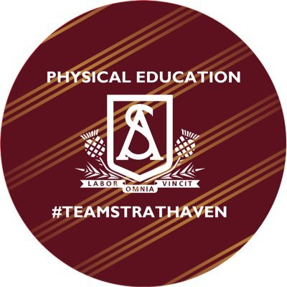](https://pbs.twimg.com/profile_images/1196085609800056832/hA5UuMBI_400x400.jpg)**WEDNESDAY PE WORKOUT**

Learning focus:

🌟 Determination and resilience

🌟Working to the best of my ability

What do you need?

👍Interval Timer - Download free from APP store

👍Water

👍PE kit

👍Music



**Round 1**

**30 seconds High Knees**

**30 seconds Squats**

**30 seconds Plank**

**30 seconds Burpees**

**Round 2**

**30 seconds Star Jumps**

**30 seconds Sit ups**

**30 seconds Burpees**

**30 seconds Punches**

Rest

(select what time is best for you)

🥉 40 seconds

🥈 30 Seconds

🥇 20 Seconds

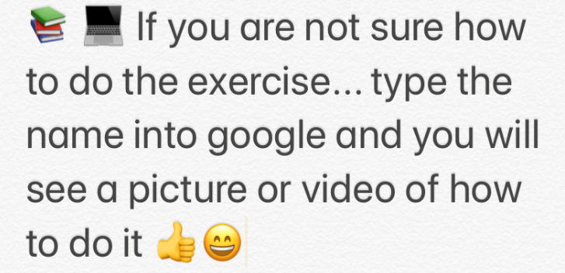**c**

REPEAT CIRCUIT 2/3 TIMES

STRETCH TO FINISH

MORE FITNESS WORKOUTS AT @STRATHAVENPE

Rest

(select what time is best for you)

🥉 40 seconds

🥈 30 Seconds

🥇 20 Seconds

Rest

(select what time is best for you)

🥉 40 seconds

🥈 30 Seconds

🥇 20 Seconds

**Round 3**

**30 seconds Lunges**

**30 seconds Mountain Climbers**

**30 seconds Push ups**

**30 seconds fast feet**