Strathaven Academy
Literacy Committee
Dear Parent/Carer,
The literacy challenge booklet has been designed to encourage your child to work independently and to encourage progression and enjoyment in reading from primary/S1. It should also help your child to develop good study habits.
Your child will be expected to read every day and to log their reading habits. Pupils are expected to set their own challenging target of up to 30 texts* across the session. Pupils are encouraged to read a variety of texts, to borrow books from the school and class libraries or to bring books from home or the local library.
Numerous educational studies point to the link between a regular reading habit and educational improvement. Pupils are therefore given time to read in registration and during English class and are expected to bring a book and their Literacy Challenge booklet with them every day.
We also ask pupils to read for at least 10 minutes at home every day. This forms the daily homework set by the English Department.
Reading is supported and encouraged throughout the school; we celebrate reading across the curriculum during Reading Week and every department has contributed a subject-specific reading exercise to the Literacy Challenge which pupils will complete as homework when requested to do so.
The rest of the Literacy Challenge booklet forms the bulk of the homework programme for the English Department. Pupils will be set a weekly or fortnightly task designed to allow pupils to reflect on what has been read and enjoyed.
The good habits that homework develops should be highly regarded and to achieve the most from these exercises pupils should complete them on time and to the best of their ability. Should there be any concerns about the progress your child is making the school will keep you informed.
In the meantime, should you have any concerns or questions please do not hesitate to contact Helen Bradshaw on 01357 524040
The English Department (on behalf of the Literacy Committee)

Parent/Carer’s signature ______________________________
Pupil Signature: ______________________________________
*Texts are defined as: novels, short stories, plays, poems, reference texts, the spoken word, charts, maps, graphs and timetables, advertisements, promotional leaflets, comics, newspapers and magazines, CVs, letters and emails. films, games and TV programmes, posters, recipes, manuals and instructions, reports and reviews , blogs and social networking sites, web pages, catalogues and directories
Strathaven Academy Literacy Challenge Date Set: ______________ Date Due: ____________

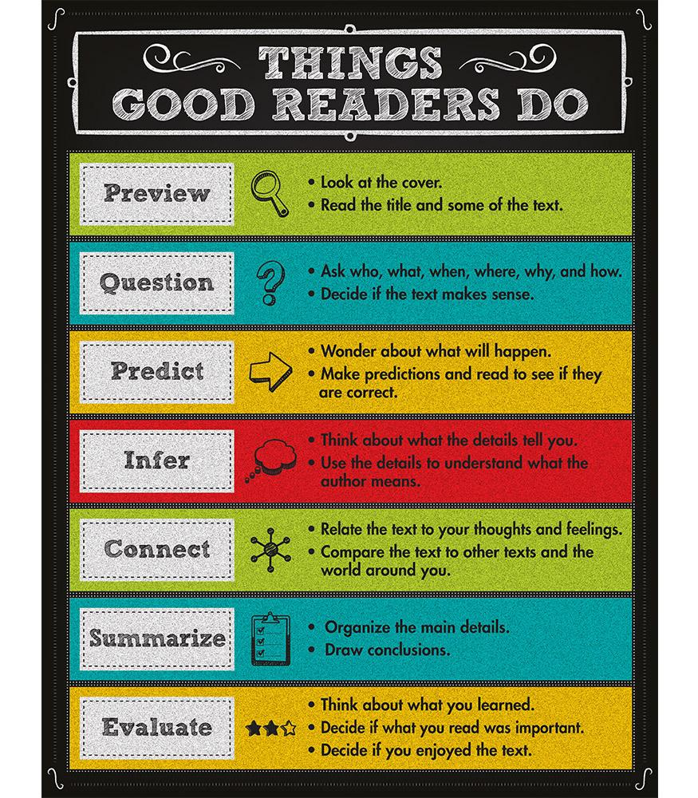

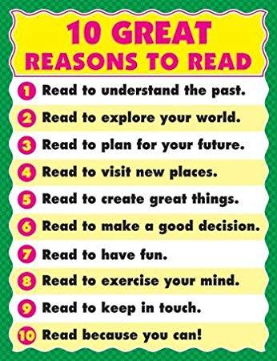

Real Reading
- Focussed on pages (actually reading the words)
- No talking
- Pacing (fluency)
- Not wanting to put it down
- Asking questions
- Visualising (mental images
- Making predictions
- Confirming/revising predictions
- Being totally mesmerised
- Putting yourself in the character’s shoes
Fake Reading
- Not reading the pages
- Flipping the pages
- Only looking at pictures
- Reading entire chapter/book in 5 minutes
- Looking around
- ‘Pretending’ to be reading
- Skipping pages
- Staying on the same page
- Talking with friends
- Generic comments

VS

We challenge you to read as much as you can this year! Choose your challenge!

My Reading Challenge Record
Title of Text Author Date Completed

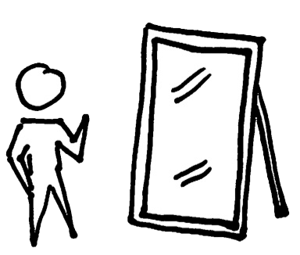
Reading Reflections
You should regularly reflect on your reading. Here you can have a ‘conversation’ with your teacher about your reading.
- What are you liking/disliking about your book?
- What puzzles you about the text?
- Does it remind you of anything else?
- What do you think will happen next?.........
Week beginning: _____________ Reading Reflections

Week beginning: _____________ Reading Reflections

Week beginning: _____________ Reading Reflections

Week beginning: _____________ Reading Reflections

Week beginning: _____________ Reading Reflections

Week beginning: _____________ Reading Reflections

Week beginning: _____________ Reading Reflections

Week beginning: _____________ Reading Reflections

Week beginning: _____________ Reading Reflections

Week beginning: _____________ Reading Reflections

Week beginning: _____________ Reading Reflections

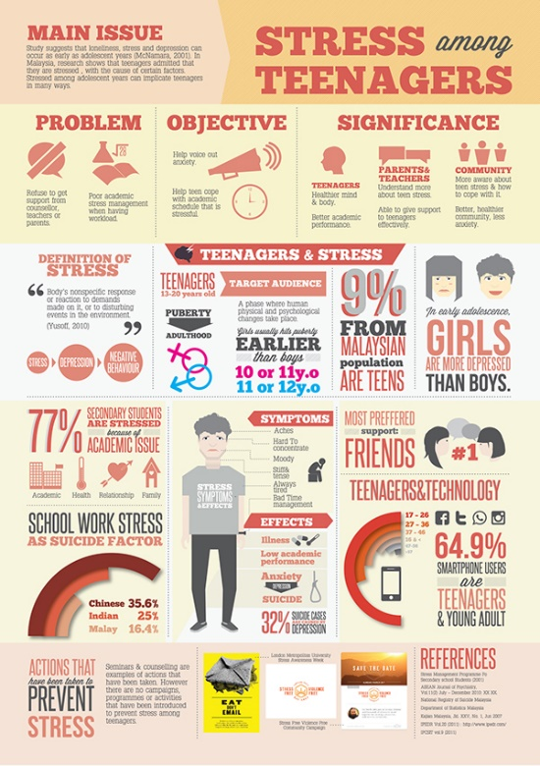
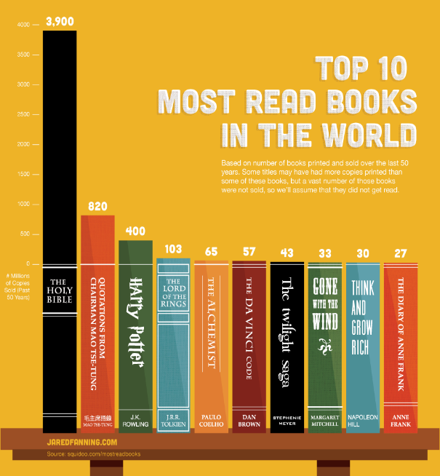
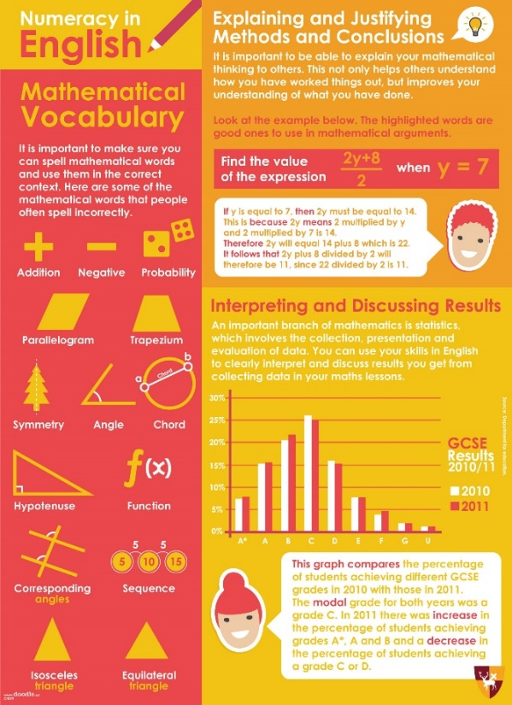

S2 Numeracy Week Reading Challenge: Infographics

At school we often have to read to find information and the way that information is presented can make a huge difference to our ability to retain that information.

Infographics are visual representations of information, data or knowledge which present us with information quickly and clearly. Because they are colourful and engaging they can help to improve readers understanding and ability to remember information.

Your challenge this week is to research and find the most interesting infographic.

Write down what the infographic was about and what was good about how it displayed its information
__________________________________________________________________________________________________________________________________________________
Now write down the most interesting piece of information you learned from the infographic
__________________________________________________________________________________________________________________________________________________
Strathaven Academy Literacy Challenge Date Set: ______________ Date Due: ____________

Reading Challenge: Write a 100 word summary of your book – NOT 101 or 99…100 exactly!

Strathaven Academy Literacy Challenge Date Set: ______________ Date Due: ____________

Reading Challenge: Write a 100 word summary of your book – NOT 101 or 99…100 exactly!

Strathaven Academy Literacy Challenge Date Set: ______________ Date Due: ____________
Speed Dating

Prepare a short summary – thirty seconds to a minute long – selling the book you are currently reading to a classmate.
During class time you will take your summary speed dating.
You need to be able to sell your book
and listen to your partner’s summary before
you move on.
At the end you must write
the name of the book you
most liked the sound of
on a post it note.

Strathaven Academy Literacy Challenge Date Set: ______________ Date Due: ____________
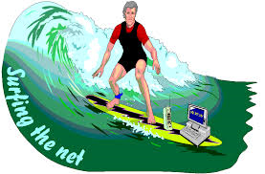

Find 5 internet sites that others might check out before they read your book so that they will know more about the book’s setting, context or time period.
‘The Ruby in the Smoke’ by Philip Pullman
Victorian London - http://www.aboutbritain.com/articles/victorian-london.asp
Penny Dreadful comics - https://www.bl.uk/romantics-and-victorians/articles/penny-dreadfuls
Victorian workhouses - http://www.primaryhomeworkhelp.co.uk/victorians/workhouses.html
The role of women in Victorian era – http://logicmgmt.com/1876/overview/victorian_woman/victorian_woman_employment.htm
Orphans in Victorian times - https://prezi.com/aruuptxmlaqw/treatment-of-orphans-in-victorian-times/

Strathaven Academy Literacy Challenge Date Set: ______________ Date Due: ____________
PERSUASION
Over the next few weeks you are going to think about persuasion and the techniques used to
persuade people. Then you are going to write persuasively on an issue about which you feel
strongly.

PERSUASION TASK 1
For your first task think about and try to answer the following questions in as much detail as you can.
- What is persuasion?

- Write down as many words as you can think of which mean the same thing as persuasion or something similar.

- Why is it important to be able to spot persuasive language? Try to give at least 2 reasons.

- In which places would you find persuasive language? e.g. a TV advertisement

Strathaven Academy Reading Challenge Date Set: ______________ Date Due: ____________
PERSUASION TASK 2
Now look at some examples of persuasive writing.
Example 1 – Mum can Ah get?
Mum can Ah get? Mum, can Ah get that? Oh Mum, can Ah, please? Ah promise Ah’ll be good. Ah’ll no ask for anything again. Oh please Mum, can Ah just have it? It’s no fair. Ah never get anything. Dee-Anne gits whatever she wants. Ah never got anything when she got her new shoes last week. Ah want a new paira shoes.
Oh look, Mum, those shoes are dead nice, in’t they? Oh so ur they wans oer there. No they wans o’er there are nicer. Can ah get them Mum? They’d go nice wae ma wee black skirt. Oh Mum, Ah’ve got tae have them. Please. Ah’ll be able tae wear them tae Nicole’s birthday party the morra. Aw ma pals are getting somethin new tae wear. Oh please mum can ah get them?
Ah can! Oh great Mum! Ah’ll no ask for anything else. Ah promise! Ah’ll still need to find a top tae wear. Ah’ll probably have tae wear that auld cream top Ah wish Ah had a new top tae wear.

Read the text out loud.
How does the girl try to persuade her mum to buy her the new shoes?
Highlight or underline all of the ways the girl tries to persuade her mum.

Now look at what you have highlighted. Can you give a name to any of the techniques used by the girl? Write your answers/ideas here.

Example 2 – Oxfam Leaflet
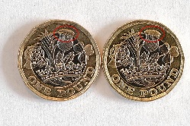
- Read the text over and look at it closely. How does the leaflet persuade you to give money to Oxfam? Again highlight or circle all the techniques used.

- Then write down a list of the techniques.

- Do you think this was a successful leaflet? Why/Why not?

- Which was the most effective technique used and why?

Example 3 - Persuasion can be everywhere and sometimes it can be so subtle you hardly notice it.
This text comes from an old-fashioned history textbook that was used in schools in the recent past. It sums up what happened when Britain discovered and claimed new countries.

Read it over twice.

- Find all the words and phrases used to suggest that the British invaders were in the right. Write down 3.

- What attitude does the author seem to have towards the people who already inhabited these countries?

- How did you work this out – what words/phrases suggest this attitude?

- Can you think of any reasons why this type of persuasion, particularly in a school text book would be dangerous?

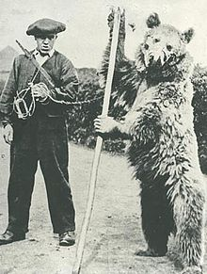
Example 4 - In this extract, a girl has written to a magazine after it printed an article about the cruelty of dancing bears. Read the letter over twice.

Letter to the editor
The Editor
Bliss Magazine
London
WC2H 8JG

Dear Sir
I read your article on dancing bears (Bliss, June 2000) with great interest. Another cruel spectator sport is bullfighting. I think this sport is disgusting. It exploits animals for fun and this is totally unfair and unjustified. The animal has to endure excruciating pain until it suffers a long drawn out death – and this is supposed to be in the name of entertainment!
In 1993, a French poll found 83% of people were against bullfighting. Now many towns have been forced to stop putting on fights because of widespread opposition. I do appreciate that in some areas bullfighting has a long tradition and that it is part of Spanish culture. But, I feel that there should be no place for it in today’s society.

Yours sincerely

Sophie Hall

- Is the letter convincing? Why/why not?

- What techniques has the girl used?

- Check out the facts and the sources for the facts.

- How could it be improved?

Strathaven Academy Reading Challenge Date Set: ______________ Date Due: ____________
PERSUASION TASK 3
Now that you have completed and gone over these exercises as a class, make a table of all the techniques used to persuade. The first couple are done for you.

Technique | Definition | Example
Emotive Language | Words which are designed to suggest the feeling of the writer e.g. anger, and to create the same feeling in the reader | ‘excruciating pain’  ‘cruel’
Superlatives
Rhetorical Questions
Commands
Addressing the reader

Strathaven Academy Reading Challenge Date Set: ______________ Date Due: ____________
PERSUASION TASK 4
Sometimes we feel very strongly about an issue and we want others to know and share how we feel. So, what really interests you, angers you or makes you particularly sad?

One issue many teenagers might feel strongly about is curfews for those under 16 years of age.

Imagine someone was going to persuade you of the following:

“Local Authorities should not have the power to impose curfews on the under sixteens”.

Some people who OPPOSE this might argue that:
1. Curfews would cut the number of incidences of street crime and vandalism committed by under 16s.

But to SUPPORT that statement someone might argue that:
1. Curfews are against everyone’s human rights.
2. It would destroy positive relations between police and children
3. There aren’t enough police to enforce curfews.
4. Curfew schemes e.g. in Hamilton have not been proven successful.

Here are some other statements made by teenagers about issues on which they hold strong views.
- School Uniform should be banned
- Parents should not have the right to smack their children
- Scotland should be an independent country
- The sale of fireworks to members of the public should be banned
- People who are terminally ill or severely handicapped should be allowed or even helped to die
- Mobile phones at school should be banned
- People should not be allowed to keep dangerous dogs
- Violent video games have a negative effect on children

Do you feel strongly about any of these issues?

Perhaps you feel that the opposite of one of these statements is true, eg:

- People who are terminally ill or severely handicapped should NOT be allowed or even helped to die
Choose one of the statements from the list that you agree with and write it down ________________________________________________________________

NOW write down 3 or 4 reasons why you feel this way. (Again use the curfews example to help you)
1. _____________________________________________________________
2. ______________________________________________________________
3. ______________________________________________________________
4. ______________________________________________________________

NOW write down one reason that some people might OPPOSE this viewpoint. (use the curfews example to help you) _______________________________________________________________

Do the same for another of the statements STATEMENT NOW write down 3 or 4 reasons why you feel this way.
1. ______________________________________________________________
2. ______________________________________________________________
3. ______________________________________________________________
4. ______________________________________________________________

NOW write down one reason that some people might OPPOSE this viewpoint. 1. ________________________________________________________________

Strathaven Academy Reading Challenge Date Set: ______________ Date Due: ____________

PERSUASION TASK 5

Your task is to write a short persuasive essay about one of the statements you chose last week.
(If there is another issue about which you feel strongly you can choose this instead but you will need to clear it with your teacher first)

In order to write in a convincing way, you need to have some facts and statistics you can use. In order to obtain this, you need to do some research.
Your teacher will allow you one period of research either with the Chromebooks or in the library or an ICT suite but you should do some of your own research too.

In order to research effectively you need to be able to do 2 things:
1. Make effective notes
2. Keep a bibliography

Before you start your research you need to refresh your note making skills. Note making is an
essential skill which you will use in every subject area. Here are some tips to improve your note-making skills.
- Be selective. You can’t write everything down from a book or website so pick out the things that you feel are most important.
- The important thing to remember is to put the important points into your own words because plagiarism (to steal someone else’s ideas and pass them off as your own) is very serious
- Don’t write in sentences. Instead use some or all of the following techniques:
  - Headings and subheadings
  - Bullet points
  - Lists
  - Diagrams/spider diagrams/flow charts
  - Underline keywords or use CAPITALS to emphasise key ideas
  - Use coloured pens or highlighters
  - Use shorthand, e.g. soc. = society; w/in = within; w/out – without; h/work = homework;
  - Use textspeak (as long as you will understand what you have written and can write words out in full when it comes to using the information
  - Use abbreviations: etc., e.g., i.e., n.b.
  - Use symbols as shorthand.

TASK: Look at the following example of how one pupil made notes from a passage about
evacuation. Then do the same for the passage on cobras.
Jenny has to study the topic of evacuation since she expects to be asked questions on the Second World War in her History exam.
EVACUATION
The Government introduced the evacuation scheme to prevent children being exposed to the great danger, sense of panic and possible loss of life which would be experienced in cities during the war. Children would assemble at their schools and would be taken with their teachers by train to safer, more rural places. When they arrived, they would be selected by local people who had space in their houses, and taken to their homes where they would be looked after. There were a number of problems. Many of the city children found it hard to adjust to a new environment, and some of their hosts expected better manners and behaviour from the children, many of whom had come from deprived industrial area. However, many of the children benefited from the fresh air and good fresh food, and so they became much healthier.

Here Jenny has reduced the passage to its MAIN POINTS

EVACUATION
- Govt. introduced scheme to protect children from fear/danger in cities.
- Assembled at school. Travelled with teachers by train.
- Local people with space took them in.
Problems:
- children found it hard to adjust
- hosts expected better behaviour, etc.
Benefits
- fresh air/good food
- healthier

She has decided to use a spider diagram to reduce the information to KEY WORDS which will help her to recall the information she needs in her exam.

She might also have used the Cornell Method of note-taking. This is useful for taking notes from a source – you pick out all the relevant ideas and over time reduce and summarise what you have learned.

For example:
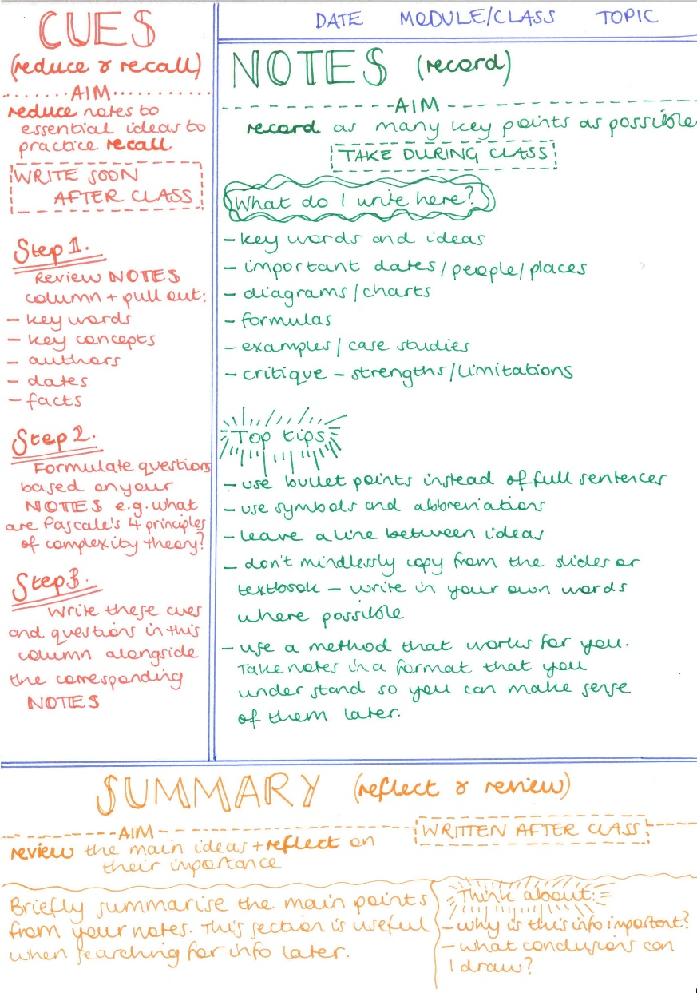
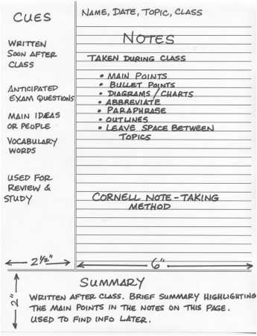

Choose one of these methods to take notes from the passage on Cobras.

COBRAS
Cobras are found in hot tropical places, such as Africa and India. When they are angry, they push out their ribs so that the skin behind their heads looks like a hood. There are many types of cobra. They are usually less than two metres long, but the King Cobra can reach three metres.

Cobras lay their eggs in damp places. They feed on small mammals such as mice, and on birds and frogs. They may enter houses in search of food. They are very dangerous animals, for the cobra’s bite it one of the most poisonous of all snake bites. A victim might die unless a serum is injected
straight away.

Cobras with their fangs removed have been used by ‘snake charmers’ the charmers play on musical instruments and the snakes sway to and fro as if they are ‘charmed’ by the music.

Strathaven Academy Reading Challenge Date Set: ______________ Date Due: ____________

PERSUASION: WRITING A BIBLIOGRAPHY

A bibliography is a list of sources (books, leaflets, websites, etc.) which you have consulted in
carrying out your research.

You must keep a record of the sources you have used to include in a bibliography at the end of your work

You can set it out like this.
BIBLIOGRAPHY
- www.bbc.co.uk – news article dated 16th May 2003
- Hindley, Geoffrey, 1979, World Art Treasures, Pages 20- 23

Here are some useful websites to get you started:
- www.bbc.co.uk
- www.independence.co.uk – select ‘issues online’ THEN username; Fulton THEN password: 18616 THEN search keywords
- Websites for newspapers, e.g. www.theherald.co.uk or www.theguardian.co.uk
- theday.co.uk Login: Strathaven Password: theday
- OR you could type your statement straight into google or any other search engine and see what responses you get.

Use your 3 or 4 main points to start you off. You can add to or change your main supporting
arguments as you do your research and find out more about the topic.

You could set out your notes like this

Strathaven Academy Reading Challenge Date Set: ______________ Date Due: ____________
PERSUASION TASK 6
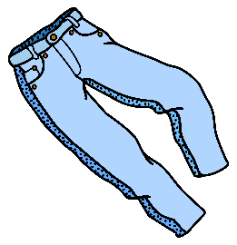
Before you go on to write your essay you need to think about how best to present your argument in a convincing and persuasive way. So look at a couple of examples.

Read :
Trousers4girls

There are still many schools where girls are forbidden from wearing trousers as part of their uniform. I am sick of girls being discriminated against in this way. In school teachers say that everyone is equal and that they should be treated the same. However, in this instance, girls are being discriminated against and the school uniform policy blatantly contradicts this statement.

Firstly, I feel that girls should be allowed to wear trousers because girls get cold too. The current fashion is that skirts should be worn really short. No-one would be seen dead in a long skirt. In winter, this means that we freeze to death or have to wear sticky, itchy tights, which are uncomfortable and expensive. And, if we don’t wear tights, we have to shave our legs every day or worse still suffer the excruciating pain of having them waxed.

Secondly, trousers are much more practical. Have you tried running for a bus in a skirt? We are scared to bend down to tie our shoe laces in case perverts are trying to check us out. Furthermore, going up and down stairs and sitting down is a total nightmare. If we wear short skirts, parents and teachers are constantly on our backs saying that our skirts are too short and reveal far too much. This problem of indecency could be solved at a stroke if only we were allowed to wear trousers.

On the other hand, the main argument against girls wearing trousers is that they are not smart or ladylike. However, I would maintain that this is the 21st century and trousers and being worn by women in all walks of life, in hundreds of countries all over the world. It is time education caught up. Come on girls! You have nothing to lose but your skirts!

- Is it well-structured? Give a reason for your answer.

- What are the writer’s 2 main supporting points?
__________________________________________________________________
__________________________________________________________________
- What is the OPPOSING argument?

- What techniques has the writer used to persuade you?

Now Read Curfews and answer the following questions

- What is the function (job) of the first paragraph?

- What is the second paragraph about?

- Can you see the 4 original SUPPORTING POINTS? Underline or highlight them.

- What does the writer do to make them clearer for the reader to follow?

- What is the function of the last paragraph?

- Overall, do you think it is an effective essay? Why/Why not?

- List 3 techniques the writer uses to persuade the reader to agree.

Strathaven Academy Reading Challenge Date Set: ______________ Date Due: ____________
TEXT 2 CURFEWS:

Local Authorities should not have the power to impose curfews on the under sixteens
Although not everybody would agree, I want to argue that the recent suggestion that curfews should be imposed on the under sixteens in order to cut the levels of youth crime is unnecessary and cruel.

Some people think that curfews are the way forward because they think such schemes will cut incidences of street crime and vandalism. They argue that telling youths when to come in will teach them to respect rules. They also feel that curfews have the best interests of the child at heart because it keeps them from making mistakes they may come to regret later.

I, however, want to persuade you that curfews for under sixteens are wrong. There are several points I want to make to support my point of view. My first reason is that it is against every person’s human rights. I believe that everyone is responsible for their own actions and therefore all children and their guardians should make their own decisions about what time they have to be home. Setting a curfew treats all children as guilty as a nightly curfew would affect law abiding children as well and curfews simply punish them for the actions of others. There was a curfew scheme in place in areas of Hamilton until recently and I agree with Mr John Scott, Chairman of the Human Rights Centre who said the scheme was a failure as it “harassed decent children who were committing no crimes”.

A further reason is that curfews would destroy any positive relations between children and the police. It will be the policemen and woman who have to enforce the curfew and children will soon learn not to trust or respect them as a result. This may mean that children will be less likely to go to police if they are attacked or have witnessed a crime after the curfew for fear of being charged themselves for curfew violation.

Moreover, enforcing a curfew would involve many more police than are on the streets currently. Since 1997 there has been a significant drop in the number of police officers. It seems to me that there are not enough to do this job and as a result crime would still be committed because there will be areas left free from police. I believe that the police should be out catching the real criminals instead of taking children committing no crimes off the streets.

Furthermore, any curfew schemes there have been already have not been proven successful. Residents in Hamilton have said that they believe the curfew has done nothing to deter youngsters and some say behaviour is as bad as ever. After all, how many people who choose to ignore laws about burglary and violence do you think will obey a curfew law! The curfew did reduce crime in the immediate area in Hamilton but it simply shifted crime to the neighbourhoods surrounding where the number of crimes committed rose. I think it is appalling that people still agree with curfews although they have been proved unsuccessful and would affect the majority of youths when it is only a minority of young people who cause trouble.

These arguments show that curfews are not the right solution to the problem of youth crime.
Therefore, although some people argue that they are the only way to control teenage misbehaviour I think I have shown that curfews should not be enforced. Parents should be the ones who are responsible for setting times for their children to be home and for making sure they commit no criminal acts not the police or the government.

PERSUASION TASK 7
In both essays the structure is clear because of the writer’s use of topic sentences and linking words to make it clear when they are adding a new point to BUILD up their argument or when they are introducing an OPPOSING viewpoint.

You should also make use of linking words to strengthen your argument. Use the exemplars to start to build up a word bank of linking words/phrases that you could use in your essay.

Some examples have been given to start you off. Try to add at least 4 of your own to each section.

Words which show the writer is building their argument:
Firstly
Secondly
So

Words which show the writer’s argument is changing direction:
However
On the other hand

Words which are used to introduce examples:
For example
Such as

Words which show the writer is concluding:
In conclusion
Overall

Strathaven Academy Reading Challenge Date Set: ______________ Date Due: ____________
PERSUASION TASK 8
Now you have all the materials you need to write a persuasive essay just like the one on curfews
- Your strong statement with your 1 opposing argument and your 4 supporting arguments
- Your research to support your argument
- A list of persuasive techniques to use in your own writing
- A word bank of linking words/phrases
- An exemplar on curfews

Your first task is to write your introduction. There are 5 jobs an introduction needs to do. It needs to:
1. Introduce the topic
2. State why the topic is important/of interest/topical
3. State that there is a difference of opinion about this topic
4. State a clear view
5. Include at least one persuasive technique

EXAMPLE
Although not everybody would agree I want to argue that the recent suggestion that curfews should be imposed on the under sixteens in order to cut the levels of youth crime is unnecessary and cruel.

- Does this introduction do all of its 5 jobs?

- Which ones does it do well?

- How could it be improved?

EXAMPLE
To smack or not to smack – that is the question. London Mayor Boris Johnson has recently entered the debate over whether parents should be allowed to smack their children arguing that parents must have the right to smack in order to instil discipline. I see no debate. To raise a hand, or worse, to any child to teach them something is wrong is, for me, an act of utter hypocrisy.
- Does this introduction do all of its 5 jobs?

- Which ones does it do well?

- How could it be improved?
Strathaven Academy Reading Challenge Date Set: ______________ Date Due: ____________
PERSUASION TASK 9
Now write your own introduction and paragraph 2 (which should be about the opposing
argument). Use the exemplar to help you.

Title – write down your strong statement

Introduction
Although not everybody would agree, I want to argue that

Paragraph 2 – the opposing argument
Some people think that …….. because ………. They argue that
Strathaven Academy Reading Challenge Date Set: ______________ Date Due: ____________

PERSUASION TASK 10
Now using your research and your word bank, go on to write the middle section of your essay. This should be 3 or 4 main paragraphs depending on how many supporting arguments you have.
Decide on the best order for these paragraphs. Make sure you can see ways to link each paragraph to the next. Decide whether you want your strongest argument first or you want to leave it till last.

Now your teacher will tell you how many paragraphs you should complete for your next
piece of homework. Here is a framework to help you

Main section - your arguments
I, however want to persuade you that…
There are several points I want to make to support my point of view.

My first reason is…

A further reason is…

Moreover…

Furthermore…

Don’t forget what the success criteria are for persuasive writing
In PERSUASIVE writing I can:
- Present a point of view with relevant supporting detail or evidence
  - Organise and structure ideas/info in a logical way
  - Use signposts to make structure/argument clear
  - Effectively introduce making purpose clear and engaging audience
  - End with a conclusion that sums up line of thought
  - Use technical terms/jargon
  - Use language techniques to influence/persuade reader
  - Acknowledge sources appropriately
Strathaven Academy Reading Challenge Date Set: ______________ Date Due: ____________
And the core expectations for every piece of writing
* Present work clearly and neatly
* Make sure your writing has a logical structure
- a clear introduction
- Use topic sentences
- Use linking words
- A clear conclusion
* Use capital letters and full stops
* Use paragraphs accurately
* Use terms correctly
* Use language which suits they type of writing
* Always check spelling
* Use punctuation to make the meaning of your writing clear

PERSUASION TASK 11
All that is left is to finish off your essay neatly. Here is the curfews example for you to look at again.

Example
These arguments show that curfews are not the right solution to the problem of youth crime. Therefore, although some people argue that they are the only way to control teenage misbehaviour I believe I have shown that curfews should not be enforced. Parents should be the ones who are responsible for setting times for their children to be home and for making sure they commit no criminal acts not the police or the government.

Notice that the conclusion needs to:
- Restate the strong point of view of the writer
- Present one or two general sentences which summarise the arguments
- Refer again to the opposing argument
- Include a suitably persuasive final sentence

- Skilful writers find a way to link their introduction and conclusion too– an idea, an image, a technique

NOW complete your essay by writing your own conclusion and bibliography

FINALLY, staple your completed essay into your green jotter, remembering to add some reflection on this unit and on your essay itself.
Strathaven Academy Reading Challenge Date Set: ______________ Date Due: ____________

