Strathaven Academy
Literacy Committee
Dear Parent/Carer,
The literacy challenge booklet has been designed to encourage your child to work independently and to encourage progression and enjoyment in reading from primary/S1. It should also help your child to develop good study habits.
Your child will be expected to read every day and to log their reading habits. Pupils are expected to set their own challenging target of up to 30 texts* across the session. Pupils are encouraged to read a variety of texts, to borrow books from the school and class libraries or to bring books from home or the local library.
Numerous educational studies point to the link between a regular reading habit and educational improvement. Pupils are therefore given time to read in registration and during English class and are expected to bring a book and their Literacy Challenge booklet with them every day.
We also ask pupils to read for at least 10 minutes at home every day. This forms the daily homework set by the English Department.
Reading is supported and encouraged throughout the school; we celebrate reading across the curriculum during Reading Week and every department has contributed a subject-specific reading exercise to the Literacy Challenge which pupils will complete as homework when requested to do so.
The rest of the Literacy Challenge booklet forms the bulk of the homework programme for the English Department. Pupils will be set a weekly or fortnightly task designed to allow pupils to reflect on what has been read and enjoyed.
The good habits that homework develops should be highly regarded and to achieve the most from these exercises pupils should complete them on time and to the best of their ability. Should there be any concerns about the progress your child is making the school will keep you informed.
In the meantime, should you have any concerns or questions please do not hesitate to contact Helen Bradshaw on 01357 524040
The English Department (on behalf of the Literacy Committee)

Parent/Carer’s signature ______________________________
Pupil Signature: ______________________________________
*Texts are defined as: novels, short stories, plays, poems, reference texts, the spoken word, charts, maps, graphs and timetables, advertisements, promotional leaflets, comics, newspapers and magazines, CVs, letters and emails. films, games and TV programmes, posters, recipes, manuals and instructions, reports and reviews , blogs and social networking sites, web pages, catalogues and directories
Strathaven Academy Literacy Challenge Date Set: ______________ Date Due: ____________

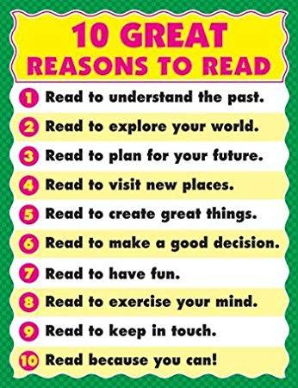

Real Reading
- Focussed on pages (actually reading the words)
- No talking
- Pacing (fluency)
- Not wanting to put it down
- Asking questions
- Visualising (mental images
- Making predictions
- Confirming/revising predictions
- Being totally mesmerised
- Putting yourself in the character’s shoes
Fake Reading
- Not reading the pages
- Flipping the pages
- Only looking at pictures
- Reading entire chapter/book in 5 minutes
- Looking around
- ‘Pretending’ to be reading
- Skipping pages
- Staying on the same page
- Talking with friends
- Generic comments

VS

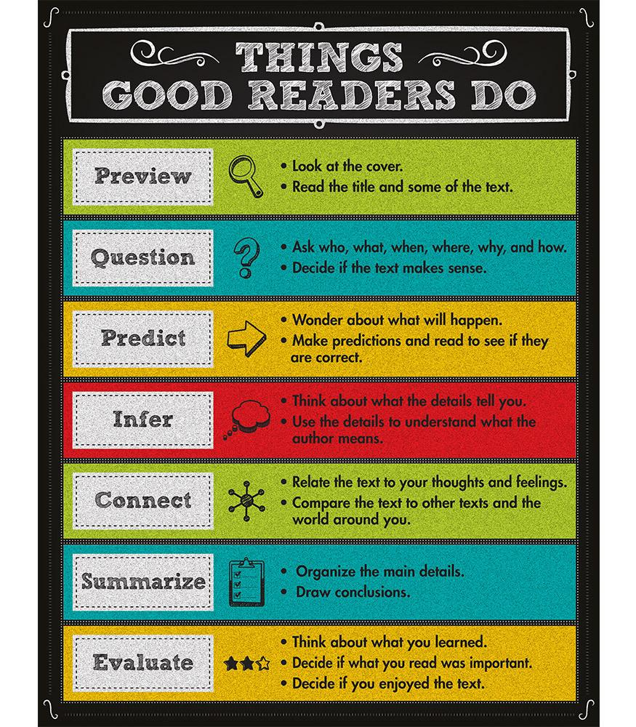

We challenge you to read as much as you can this year! Choose your challenge!

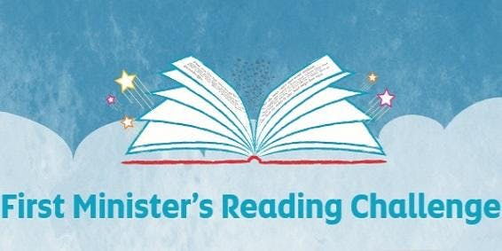
My Reading Challenge Record
Title of Text Author Date Completed

Reading Challenge
S1 Numeracy Week

Snowball Poetry

A snowball poem is a poem in which you start with one word and then move to two words in the next line and then three words in line three and so on. The poem can continue to climb or it can come back down again.

Your task is to write a snowball poem on a topic of your choice.
Each line must have one more word than the previous line.

For example

Cold.
Numb fingers.
My breath freezes.
Can't feel my toes.
I have sent for help.
Please God, when will it come?
I have done nothing to deserve this.
Stuck out here in the wind and snow.

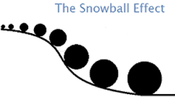
Strathaven Academy Literacy Challenge Date Set: ______________ Date Due: ____________

Choose a quotation from a character or a poem or a story or a song that you love.
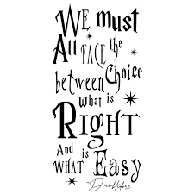
Illustrate your quote so that others will love it too!

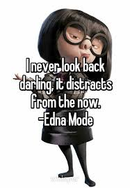

Strathaven Academy Literacy Challenge
Date Set: ______________ Date Due: ____________
Found poetry is a type of poetry created by taking words, phrases, and sometimes whole passages from other sources to make poetry (like a literary equivalent of a collage) by making changes in spacing and lines, or by adding or deleting text, thereby making new meaning.
Look at the examples below and then, using a page from your reading book, make a found poem of your own (you don’t have to photocopy or write on your book like the examples – you can just write out your poem).

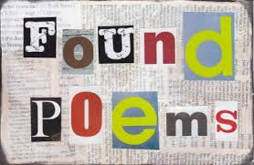

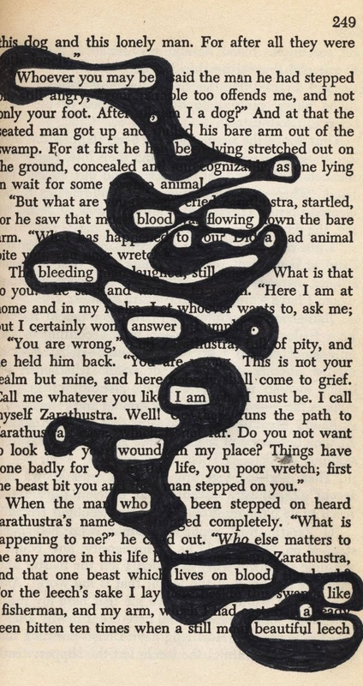

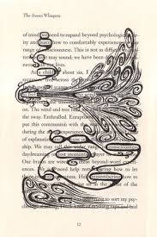
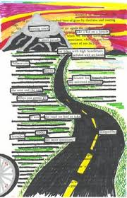
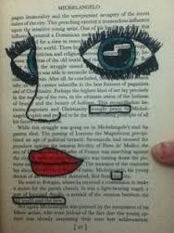
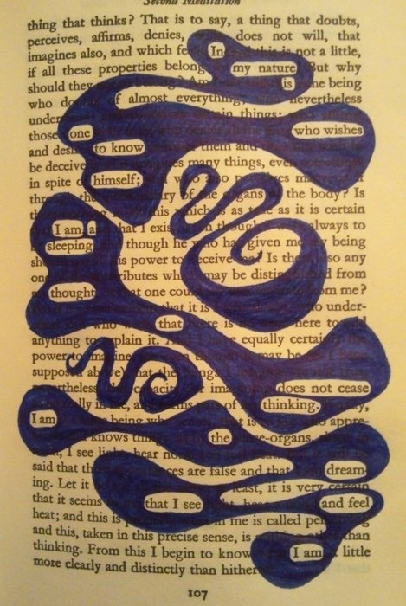

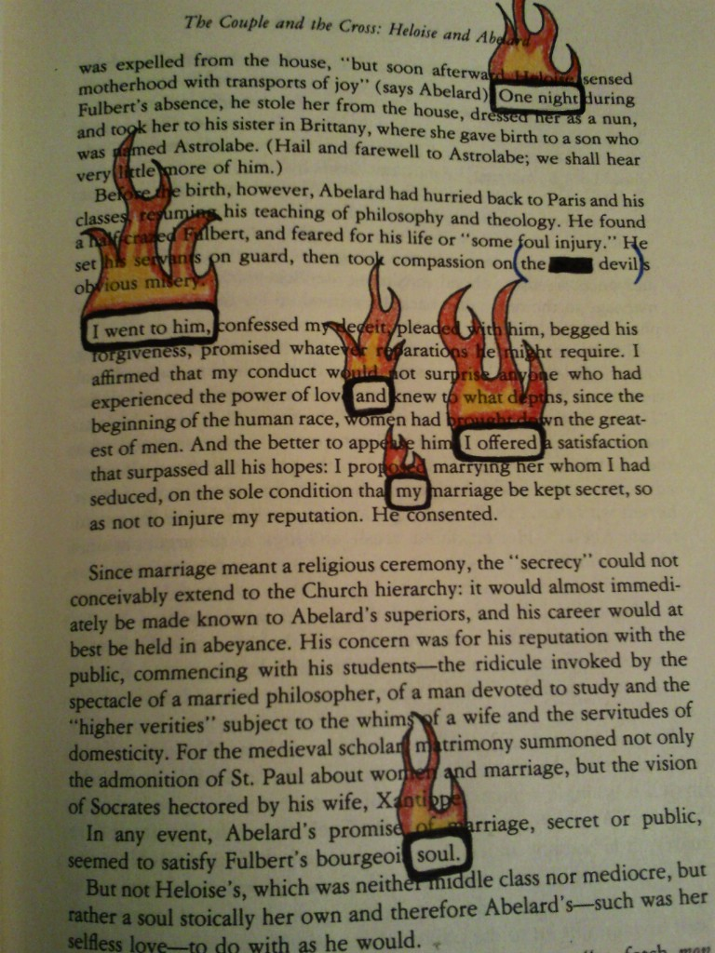

Strathaven Academy Literacy Challenge Date Set: ______________ Date Due: ____________

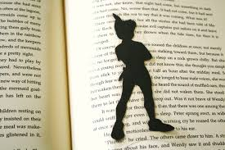
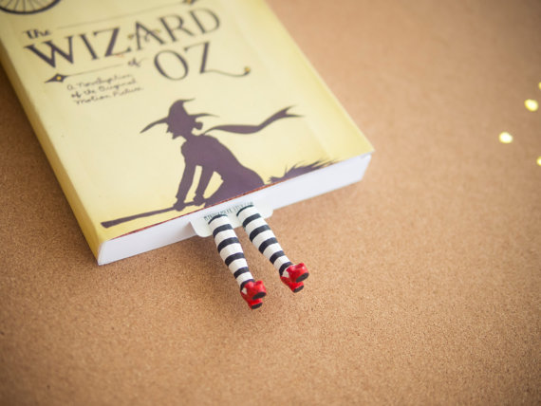

Bookmark!
Make a bookmark for your favourite or current reading book.
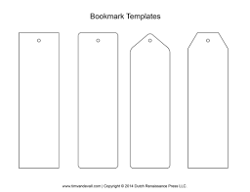

Strathaven Academy Literacy Challenge Date Set: ______________ Date Due: ____________
Write your own blurb to your favourite and/or least favourite books.

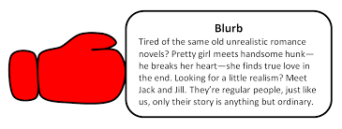
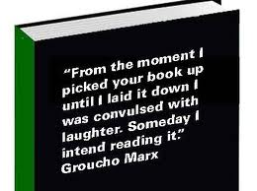

Strathaven Academy Literacy Challenge
Date Set: ______________ Date Due: ____________

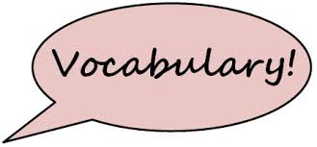

Create a 10 word glossary of unfamiliar words used in your book. Find and write down the definitions for each.

Word Definition
1
2
3
4
5
6
7
8
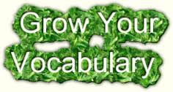
9
10
Strathaven Academy Literacy Challenge
Date Set: ______________ Date Due: ____________

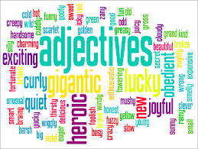
Adjective-itis

Pick five adjectives for the book or character (s) and explain how they apply.
Powerful = This book has the power to make
people think about big issues like
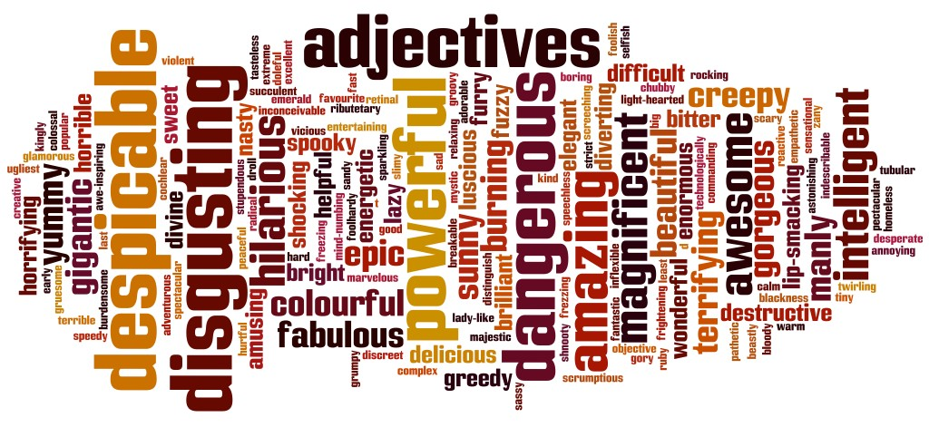
racism and prejudice

Strathaven Academy Literacy Challenge Date Set: ______________ Date Due: ____________
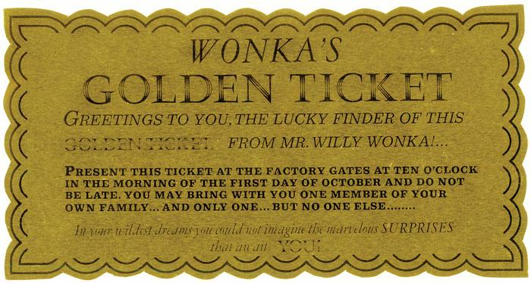
The Ferris Wheel (Charlotte’s Web by E B White)
The Ferris Wheel in Charlotte’s Web makes me sad. It is a sign that Fern is leaving one world behind and entering the ‘adult world’ – just as Dr Dorian predicted she would. It’s just like the bell in The Polar Express. Fern heard the animals talking to one another, but now she chooses Henry Fussy over Wilbur and Charlotte.
More widely the wheel in the story represents cycles and how they keep spinning. Charlotte dies but her babies live and grow and the seasons continue to change.
Choose an important object from a novel you have read. Write a paragraph to explain its importance to the story.

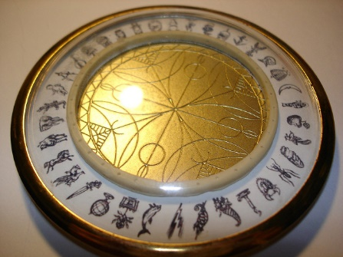

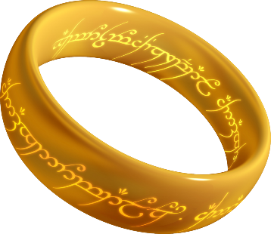

My chosen object is __________________________________________________________
From the book ______________________________________________________

Strathaven Academy Literacy Challenge Date Set: ______________ Date Due: ____________
Newspaper Challenge
Read a news article from the source below (or any other quality broadsheet newspaper or news website) and summarise the content. Use your own words.
www.bbc.co.uk/newsround/33078510
Date | Headline | Summary | Writer’s Attitude?
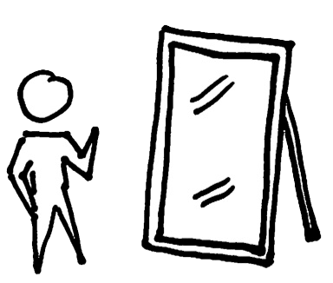
Reading Reflections
You should regularly reflect on your reading. Here you can have a ‘conversation’ with your teacher about your reading.
- What are you liking/disliking about your book?
- What puzzles you about the text?
- Does it remind you of anything else?
- What do you think will happen next?.........
Week beginning: _____________ Reading Reflections

Week beginning: _____________ Reading Reflections

Week beginning: _____________ Reading Reflections

Week beginning: _____________ Reading Reflections

Week beginning: _____________ Reading Reflections

Week beginning: _____________ Reading Reflections

Week beginning: _____________ Reading Reflections

Week beginning: _____________ Reading Reflections

Week beginning: _____________ Reading Reflections

Week beginning: _____________ Reading Reflections

Week beginning: _____________ Reading Reflections

